Polytechnic University of Bucharest

Faculty of Electronics, Telecommunications and Information Technology

**License Theme:**

**IMAGES ENCRYPTION ALTGORITHM**

**WITH CHAOTIC SYSTEM**

**Proiect de diplomă**

**ALGORITM DE CRIPTARE A IMAGINILOR**

**CU SISTEME HAOTICE**

prezentat ca cerință parțială pentru obținerea titlului de *Inginer* in *domeniul Electronică și Telecomunicații*

programul de studii de licență *programul* *Tehnologii și Sisteme de Telecomunicații (ETC-TST)*

**Supervisor:**  **Student:**

Conf.dr.ing. Mircea RĂDUCANU Vlad Gabriel POPESCU

Group: 441G_TST.en

Bucharest - 2024

**TABLE OF CONTENTS**

|  |  |
| --- | --- |
| **Chapter name** | **Page** |
| **ABSTRACT**………………………………………………………………………….........  **INTRODUCTION**…………………………………………………………………….......  **Chapter 1**  **CHAOTIC MAPS**…………………………………………………………………......  1.1. Chebyshev map…………………………………………………………....…  1.2. Henon map……………………………………………………………….......  1.3. Logistic map……………………………………………………………....…  1.4. Tent map………………………………………………………………....…..  1.5. Sine map (SSM)…………………………………………………………......  1.6. 2D Sine Logistic Couplong Map (2D-LSCM)…………………………....…  1.7. 2D Chebyshev-Sine Map (2D-CSSM)…………………………………....…  1.8. 2D Henon-Sine Map (2D-HSM)………………………………………....….  **Chapter 2**  **PERFORMANCE MATRICS** …………………………………………………....….  2.1. Peak Signal-to-Noise Ratio (PSNR)……………………………………....…  2.2. Entropy analysis…………………………………………………………......  2.3. Pixel number change rate (NPCR)………………………………………......  2.4. Unified average intensity of chage (UACI)………………………………....  2.5. Correlation coefficient…………………………………………………....….  **Chapter 3**  **IMAGE ENCRYPTION PROCESS**……………………………………………….  **Chapter 4**  **EXEMPLES OF IMAGE ENCRYPTION ALGOTYTMS WITH**  **CHAOTIC MAPS**……………………………………………………………………..  4.1. A hashbased fast image encryption algorithm………………………………  4.2. A Parallel Encryption Algorithm Based on Piecewise Linear Chaotic Map...  4.3. An image encryption algorithm based on balanced pixel and Chaotic Map...  4.4. Image encryption algorithm based on the enhanced Sine-Tent Map………..  4.5. Image encryption using the Josephus chaotic matrix………………………..  4.6. An image encryption scheme based on the Lorenz hyperchaotic system and  the RSA algorithm…………………………………………………………  4.7. Image encryption scheme based on generalized Arnold map and RSA  algorithm.…………………………………………………………………….  4.8. Image encryption scheme based on new 3D chaotic mapping……………...  4.9. Image Encryption Technique Based on Sinusoidal Map, Chaotic  Choropleth Map, and Circulant Matrix………………………………………  4.11. Image encryption algorithm based on Chebyshev, Henon and Logistic MAPS…………………………………………………………………………………..  **Chapter 5**  **IMAGE ENCRYPTIONN ALGORITH DESIGN SOLUTION**…………………...  5.1. The encryption algorithm scheme…………………………………………...  5.2. Explain the Algorithm concept………………………………………………  5.3. Explanation of stage of the code designed…………………………………..  5.3.1. Read/Load Input Image and Display…………………………………..  5.3.2. **Convert to Grayscale and Normalize…………………………………..**  5.3.3. **Initialize Chaotic Systems and Parameters…………………………….**  5.3.4. Generate Chaotic Sequences…………………………………………...  5.3.5. Encryption Function…………………………………………………...  5.3.6. Image Decryption……………………………………………………...  5.3.7.Calculate Performance Metrics in Algorithm………………………….  5.3.8. Display and Analysses the results……………………………………...  **Chapter 6**  **INTEGRATION INTO MATLAB**…………………………………………………...  6.1. The parallelization procedure………………………………………………..  **Chapter 7**  **TABLES OF RESULTS**…………………………………………………………….  Table 7.1. General information about the photos used in the algorithm of this  Project………………………………………………………………..  Interpretation of the results in the table 7.2 …………………………  Table 7.2. Calculated performance metrics results……………………………...  Table 7.3. The results of Image encryption algorithm with Chebyshev, the  Henon and the Logistic chaotic systems……………………………..  Table 7.4. ENTROPY, NPCR AND UACI METRIC COMPARISON…………  Interpretation of the results in the table 7.4 …………………………  **Chapter 8**  **FIGURES, GRAPHICS AND HISTOGRAMS OF RESULTS**…………………...  Fig. 8.1. The original images with their histograms and the encrypted images  with their histograms…………………………………………………..  Fig. 8.2. The original images with their pixels correlation and the encrypted  images with their pixels' correlation…………………………………...  Fig.8.3 The graphics of Horizontal, Vertical and Diagonal correlation  coeficients for Original, Encrypted and Decrypted Picture:  Baboonn_256.jpg in color map and grey map…………………………..  Fig.8.4 The graphics of Horizontal, Vertical and Diagonal correlation coeficients for Original, Encrypted and Decrypted Picture: Barbarra_256.jpg in color map and grey map………………………….  Fig.8.5 The graphics of Horizontal, Vertical and Diagonal correlation coeficients for Original, Encrypted and Decrypted Picture: Bonzzai_256.jpg in color map and grey map…………………………..  Fig.8.6 The graphics of Horizontal, Vertical and Diagonal correlation coeficients for Original, Encrypted and Decrypted Picture: F16_256.jpg in color map and grey map……………………………….  Fig.8.7 the graphics of Horizontal, Vertical and Diagonal correlation coeficients for Original, Encrypted and Decrypted Picture: Lenn@_128.jpg in color map and grey map…………………………...  Fig.8.8 The graphics of Horizontal, Vertical and Diagonal correlation coeficients for Original, Encrypted and Decrypted Picture: Lenn@_256.png in color map and grey map…………………………...  Fig.8.9 The graphics of Horizontal, Vertical and Diagonal correlation coeficients for Original, Encrypted and Decrypted Picture: Lenn@_512.jpg in color map and grey map…………………………...  Fig.8.10, the graphics of Horizontal, Vertical and Diagonal correlation coeficients for Original, Encrypted and Decrypted Picture: Lenn@_1024.png in color map and grey map………………………….  Fig.8.11 The graphics of Horizontal, Vertical and Diagonal correlation coeficients for Original, Encrypted and Decrypted Picture: Photographer_256.png in color map and grey map…………………….  Fig.8.12 The graphics of Horizontal, Vertical and Diagonal correlation coeficients for Original, Encrypted and Decrypted Picture: Watch_256.jpg in color map and grey map…………………………….  Fig. 8.13 The histograms of the (a) original and (b) encrypted pictures: Baboonn_256.jpeg……………………………………………………...  Fig. 8.14 The histograms of the (a) original and (b) encrypted pictures: Barbarra_256.jpg……………………………………………………….  Fig. 8.15 The histograms of the (a) original and (b) encrypted pictures: F16_256.jpg…………………………………………………………….  Fig. 8.16 The histograms of the (a) original and (b) encrypted pictures: Lenn@_128.jpg.......................................................................................  Fig. 8.17 The histograms of the (a) original and (b) encrypted pictures: Lenn@_256.png.......................................................................................  Fig. 8.18 The histograms of the (a) original and (b) encrypted pictures: Lenn@_512.jpg.......................................................................................  Fig. 8.19 The histograms of the (a) original and (b) encrypted pictures: Lenn@_1024............................................................................................  In Fig. 8.20 The histograms of the (a) original and (b) encrypted pictures: Photographer_256.png………………………………………………….  In Fig. 8.21 The histograms of the (a) original and (b) encrypted pictures: Watch_256.jpg………………………………………………………….  In Fig. 8.22 The histograms of the (a) original and (b) encrypted pictures: Bonzzai_256.jpg………………………………………………………..  **Chapter 9**  **ANALIZY THE RESULTS**………………………………………………………….  9.1. **Advantage**……………………………………………………………………  **9.2 Disadvantage…………………………………………………………………**  9.3 Improvement…………………………………………………………………  **Chapter 10**  **CONCLUSIONS**……………………………………………………………………...  **Chapter 11**  **REFERENCES**……………………………………………………………………….  **Appendix_1**  The Matlab code…………………………………………………………………  **Appendix_2**  The parallelization code………………………………………………………….  **Appendix_3**  Sensitivity Analysis and Speed code…………………………………………….  **Appendix_4**  List of abbreviations used in this work………………………………………….. | 6  6  8  9  10  11  12  13  13  14  15  16  16  16  18  18  19  21  22  22  22  22  22  23  23  23  24  24  24  26  26  27  27  27  28  28  28  29  29  29  30  31  31  32  32  33  32  37  38  39  40  40  42  44  45  46  47  48  49  50  51  52  53  54  55  56  57  58  59  60  61  62  63  64  64  64  65  66  67  69  75  80  81 |

**ABSTRACT**

Simple transposition and substitution ciphers have given way to more complex algorithms that deal with the unique properties of digital images by using chaotic systems, which are known for being both predictable and deterministic, in a way that works well for encryption. Previous work has demonstrated their potential for creating secure encryption schemes.

            This paper presents the development of a novel image encryption algorithm that exploits three chaotic systems: the Chebyshev map, the Henon map, and the Logistic map, and we detail their definitions, equations, parameters, and roles in cryptographic algorithms. By integrating these chaotic systems with the XOR function, we propose a robust encryption scheme aimed at improving the security of digital images. This transformation is based on cryptographic algorithms that shuffle the image data, making it unintelligible without the correct decryption key.

            The introductory section defines key concepts such as chaos, chaotic maps, and their application in image processing and cryptology. Subsequent sections provide a detailed description of each chaotic map and different types of encryption algorithms, followed by the encryption algorithm's design and implementation. Simulations and a comparative analysis with existing methods validate the effectiveness of the proposed algorithm.[1]

To achieve a diverse range of results from the designed algorithm, I selected 10 frequently used photos from various works and international presentations. This approach allowed me to compare my results with those from other studies, thereby improving the analysis.

**INTRODUCTION**

In today's digital age, image encryption has become a crucial aspect of securing digital data, a critical component of data security, and ensuring the confidentiality and integrity of visual information transmitted over various communication channels. Chaotic systems have gained significant interest in the field of picture encryption because to their inherent traits of being sensitive to beginning circumstances and unpredictable. Image encryption aims to convert an image into an unrecognizable format for unauthorized users. It is a prominent technique in cryptography, which is extensively employed in digital communications. This method plays a crucial role in information security by safeguarding sensitive visual data from unauthorized access. [1].

Chaos, or chaotic, comes from Greek and means empty space, a state of disorder and confusion. chaos is the term used to describe the seemingly complex behavior of what we consider simple, and a system exhibiting chaotic behavior must fulfill several criteria concerning its trajectories in state space. These include:

                        - The different trajectories of the system must not intersect.

                        - Trajectories must be delineated.

                        - Trajectories in close proximity must move exponentially apart.

            The most crucial feature of these systems is their ability to remain within a bounded area in state space without intersecting. By chaos control or directing a chaotic system, any form of manipulation of the chaotic behavior present in a non-linear system is meant. Among the areas of broad or narrow interest in which the study of chaotic systems has recently experienced a strong development, we can mention those of narrow interest, such as power electronics, communications, where encryption using chaotic systems is of scientific and commercial interest, the field of neural networks, etc.

            One of the characteristics of modern society is computerization. Computers serve as the foundation for a multitude of information processing systems that store, process, and distribute information to users, thereby facilitating the development of modern information technologies.

            In this context, a modern information technology specialist is required to possess knowledge and skills in ensuring information security throughout the development and operation of information systems. Cryptography, a branch of modern mathematics, is concerned with the development of mathematical methods capable of ensuring message confidentiality, authentication, and non-repudiation, as well as the integrity of transmitted data.

            Encryption is a set of standards and protocols for encoding data and messages in a manner that ensures their secure storage and transmission. It forms the foundation of numerous security services and mechanisms, employing mathematical methods to transform data in order to hide its contents or protect it from alteration. This helps to ensure more secure communications, even when the transmission medium (e.g., the Internet) is not trusted. It can also be used to ensure data integrity and keep data secret, allowing for the verification of the origin of data and messages using digital signatures and certificates.

             Cryptography and cryptanalysis together constitute cryptology, which is derived from the Greek words kryptós (hidden) and λόγος (word). This topic of research focuses on the techniques and algorithms used for encoding and decoding information. Modern encryption techniques combine substitution and transposition methods with other linear or non-linear mathematical methods based on finite algebraic field theories, chaos, elliptic curves, quantum mechanics, and so on. The objective is to improve the resilience of encryption algorithms, schemes, and circuits against increasingly sophisticated and effective cryptographic attacks, given the evolution of processor, device, and Internet technologies in general.[2]

            Information confidentiality can be guaranteed by applying encryption algorithms with increased complexity and encryption keys of longer lengths and testing them to resist cryptographic attacks for a sufficiently long period of time from a given perspective.

            Traditional encryption algorithms, such as AES and RSA, are well known for their robustness. However, the increased demand for security in multimedia applications has prompted researchers to explore alternative methods, including those based on chaotic systems. These have gained significant attention due to their inherent properties, such as unpredictability, sensitivity to initial conditions, pseudo-randomness, and complex dynamic behavior.

**Chapter 1**

**CHAOTIC MAPS**

The chaotic map represents these trajectories in the horizontal plane, generalized and shrunk according to a certain scale of proportion, and drawn based on a chosen projection. Chaos theory is a field of study that focuses on the dynamics of nonlinear systems in mathematics and physics. Chaotic systems exhibit unpredictability, ergodicity, and sensitivity to initial conditions.

            Chaotic systems are deterministic systems that exhibit random-like behavior due to their sensitivity to initial and pseudo-random conditions. This property, known as the "butterfly effect," implies that small changes in the initial state of the system can lead to very different outcomes.

            The complicated random behavior and non-linear dynamics of chaotic systems are characterized by certain mathematical models called chaotic maps. We use chaotic maps to represent the temporal development of chaotic systems. Image processing uses chaotic maps for cryptography purposes to generate pseudorandom sequences.

            There are a variety of uses for chaotic maps, but three of the more popular ones are the Chebyshev Map, the Logistic Map, and the Henon Map. Compared to previous approaches, chaotic map-based picture encryption provides superior security with less mathematical complexity. To make matters worse, when variables like noise disrupt their parameters, the chaotic features of existing chaotic maps are lost due to their small or discontinuous chaotic intervals. There are two main criteria that determine how effective chaotic map-based picture encryption methods are:

            First, there has to be enough structural robustness in the encryption technique that it can resist exploitation.

            Second, how well the encryption algorithm's chaotic map works. Inadequate performance of the chaotic map jeopardizes the encryption's effectiveness and safety.

            Chaotic maps, which may be either one-dimensional or multidimensional (MD), make up the first group. The second category includes systems that exhibit hyperchaos. Systems involving space and time make up the third category.

            The use of chaotic picture encryption techniques has the benefit of producing unexpected and very sensitive beginning circumstances and control parameters for highly complicated pseudo-random sequences. The qualities of these sequences make them a top choice among chaotic systems.

            The simplicity, cheap computing cost, and ease of implementation of one-dimensional chaotic maps are their distinguishing features. Unfortunately, there are a few downsides to chaotic sequences, such as their restricted chaotic range and the fact that their output data isn't uniformly distributed.

            Multidimensional chaotic maps, on the other hand, are computationally expensive, have several parameters, and have a complicated structure. These properties make multidimensional chaotic maps challenging to implement. Nevertheless, chaotic multidimensional maps exhibit superior chaotic behavior and greater accuracy than one-dimensional maps.[3]

             A mathematically defined chaotic map is an evolutionary function that displays chaotic behavior. You may use either discrete-time or continuous-time parameters to parameterize maps. Fractals are often generated by chaotic maps and iterated functions; chaotic maps are common in the study of dynamical systems, whereas discrete mappings typically take the form of iterated functions. Rather of analyzing fractals in relation to the maps that produce them, some fractals are examined as sets. [3]

             This is frequently the case because there are several distinct iterative procedures that result in the same fractal. Chaotic maps are mathematical equations used to generate random sequences that are highly sensitive to initial conditions and control parameters. These maps fall into two categories:

            - One-dimensional (1D) chaotic maps and

            - Multidimensional Chaotic Maps (MD/2D)

             Chaotic maps are used to encrypt and scramble pictures in image processing and are perfect for creating complicated encryption keys because of their unpredictability and sensitivity to starting circumstances for use to encrypt and scramble pictures in image processing.

Chaotic maps are perfect for creating complicated encryption keys because of their unpredictability and sensitivity to starting circumstances. By utilizing these maps, it is possible to achieve a high level of security in image encryption, rendering it challenging for unauthorized parties to decrypt images without the chosen key.

**1.1 CEBYSHEV MAP**

The Chebyshev map is a polynomial sequence defined on the interval [-1, 1]. It is known for its sensitivity to initial conditions and complex dynamic behavior. The map exhibits high sensitivity to initial conditions, which causes small differences in (x) to result in significantly different outcomes after several iterations.

The Chebyshev map is defined by the following equation [4]:

xn+1 = cos(α ∙ arccos xn) where ***a*** is a positive integer and *x∈[-1,1*], (1)

The initial value, *x*, is used to initiate the chaotic sequence. The degree of the polynomial, *n*, controls the complexity of the chaotic behavior and the period of the chaotic sequence.

The Chebyshev map is employed in cryptographic algorithms due to its polynomial properties and high sensitivity to initial conditions. Its chaotic nature ensures that even minor variations in the initial value result in significantly different outputs, rendering it suitable for generating pseudo-random sequences for permutation and substitution of pixels for encryption. This map exhibits deterministic but unpredictable behavior, rendering it suitable for fast encryption algorithms.

Chebyshev map based encryption involves the generation of pseudo-random sequences using the Chebyshev map, the application of XOR to the pixel values of these sequences, and the subsequent permutation of the pixel positions using a derived sequence. This method is employed in a variety of contexts, including symmetric key cryptography, digital signature schemes, secure communication protocols, and pseudorandom number generators.

As a conclusion, the Chebyshev map is highly sensitive to initial conditions, exhibiting a complex, multi-modal structure. It is employed for generating pseudo-random sequences and for creating complex permutations of image pixels, which contribute to the encryption process.

**1.2. HENON MAP**

The Henon map is a discrete-time dynamical system exhibiting chaotic behavior. It is widely used in two-dimensional systems and is known for its chaotic attractor, which is a fractal structure representing the long-term behavior of the map. This attractor exhibits sensitivity to initial conditions and complex dynamical properties.

            The following equation represents the Henon map: The Henon map is a discrete-time dynamical system exhibiting chaotic behavior. It is widely used in two-dimensional systems and is known for its chaotic attractor, which is a fractal structure representing the long-term behavior of the map. This attractor exhibits sensitivity to initial conditions and complex dynamical properties.

            Henon Chaotic System is used to generate pseudo-random sequences by iterating *r*∙*c* times.

where (*r = M/2, c = N/2*) and *M*∙*N* is the size of the original image *I(N*∙*M), M*∙*N* is the size of the

image *I (N*∙*M)* [5].

The following equations represent the Henon map [5]:

xn+1 = 1 – ax2n + yn ,  yn+1 =bxn  (2)

where *a* and *b* are the control parameters which are regarded as secrete keys, *x0, y0* are the initial values. Because of its chaotic behavior in a two-dimensional space, the Henon map is an ideal candidate for generating complex key streams and scrambling techniques for pixel positions and values in image encryption. [5].

Its nonlinearity and simplicity provide a balance between computational efficiency and security, with strong diffusion and confusion properties. Consequently, it is an optimal choice for creating secure encryption schemes. Henon map-based encryption consists of generating sequences using the Henon map, applying XOR to the pixel values with these sequences, and finally permuting the shuffled pixel positions based on the Henon sequence.

The Henon Map's main features are:

* Two-dimensional chaotic system.
* Parameters a and b typically set to 1.4 and 0.3, respectively.
* Widely used in image encryption for its ability to distribute pixel values uniformly across the image.
* Known for its simple structure but complex behavior, leading to a uniform distribution of values.
* The Henon map's uniform distribution is beneficial for spreading pixel values across the entire range, enhancing the diffusion properties of the encryption algorithm.
* It is applied in watermarking and secure key generation, secure image transmission and multimedia security.

**1.3. LOGISTIC MAP**

The Logistic Map is a polynomial map of degree 2, which is frequently cited as an exemplar of how complex, chaotic behaviour can emerge from simple nonlinear dynamic equations.

The Logistics Map is a one-dimensional chaotic map defined by the following equation :

xn + 1 = r ∙xn∙ (1 -xn) (3)

In this context, *x* refers to the set of numbers randomly generated using a logistic system. The control parameter, *r,* determines the degree of chaos in the system. People typically set it between 0 and 4, commonly using a value of 3.57 or 4 to achieve chaotic behavior. In this range, the map is sensitive to initial conditions, resulting in complex, non-repeating sequences. We use the initial map value, *x0,* and the output sequence, *xn*, to represent the system's behavior at discrete time steps.

            Parameter: *r∈ [3.57, 4]*

            Characteristics: It exhibits chaotic behavior for certain values of *r*, making it suitable for generating pseudo-random sequences.

            Applications in Cryptography : For encryption purposes, people use the Logistic map because of its simplicity and effectiveness in generating complex, unpredictable sequences.

The bifurcation diagram demonstrates the relationship between the varying parameter values and the system's solution.

            As a quantitative indicator of chaotic behavior, the Lyapunov exponent is useful. As soon as the Lyapunov exponent is positive and greater than 0, the map displays its chaotic feature.

Figure 1.3.1 shows the logistic map's behavior, while Figure 1.3.2 shows the Lyapunov exponent and the bifurcation diagram, respectively. When *r* is between 3.57 and 4, the map becomes chaotic. The map's chaotic range is limited.

 

**Fig.1.3.1** The bifurcation diagram of Logistic Map [4**] Fig.1.3.2** Lyapunov exponent of Logistic Map[5]

The Logistic Map is a widely used component in image encryption algorithms because of its simplicity, well-documented chaotic behavior, and capacity to generate random sequences. This makes it an effective tool for pixel permutation and substitution in XOR based images, which exhibit high sensitivity to initial conditions and robust chaotic behavior.

The encryption process involves generating sequences using the Logistic map, applying XOR to the pixel values with these sequences, and finally permuting the shuffled pixel positions based on the Logistic sequence.

            The Logistic Map is employed in a number of expedient and straightforward encryption algorithms and protocols, as well as for the secure storage of data, the generation of random numbers, and the transmission of data in a stream.

**1.4. TENT MAP**

The tent map is a linear, one-dimensional map that is defined by:

xi + 1 = f(xi ,µ) (4)

f(xi ,µ) = f1(xi , µ) = µxi if xi < 0.5 and f(xi ,µ) = fR(xi ,µ) = µ(1 - xi) if xi > 0.5 (5)

where *ν* is an integer between zero and two, *x0* is the starting value, and *xi* is the output sequence from zero to one. Figure 1.4.1 displays the Tent Map's bifurcation diagram. The tent map's Lyapunov exponent is shown in Figure 1.5.1. Chaos is at its most severe when *μ* = 2.

 

**Fig.1.4.1** The bifurcation diagram of Tent Map [4**] Fig.1.4.2** Lyapunov exponent of Tent Map[5]

**1.5. SINE MAP (SSM)**

This map is a modified version of the (1D) sinusoidal map, which is defined by the following equation[4]:

xn+1 = u x sin(π x x­n) x 214 – floor( u x sin(π x x­n) x 214) (6)

where the parameter *u ∈ (0, 10],* *x0* is the initial value.

Figure 1.5.1 displays the bifurcation diagram of the sinusoidal map. Figure 1.5.2 displays the Lyapunov exponent of the Sine-Sine map. The map's range is a semi-open interval from (0 ,10]



**Fig.1.5.1** The bifurcation diagram of SSM [4**] Fig.1.5.2** Lyapunov exponent of SSM[5]

**1.6.** **2D Sine Logistic Coupling Map** **(2D-LSCM)**

This map is a two-dimensional representation that is created by combining two existing one-dimensional chaotic maps, namely the Logistic map and the sinusoidal map. The Logistic map and sinusoidal map are described as follows:

xi+1 = sin(π(4θxi(1 - xi) + (1 -θ )sin(πyi))), (7a)

yi+1 = sin(π(4θxi(1 - yi) + (1 -θ )sin(πxi+1))), (7b)

where *θ* is the control parameter *θ ∈ [0, 1].*

The trajectory shows the progression from a starting point to an increasing case over time. The chaotic system's random output may be reflected in a chaotic trajectory, which usually happens in a region of phase space.

The 2D-LSCM trajectory is shown in Figure 1.6.1. The chaotic system produces random outputs because the chaotic trajectory takes up more phase space.

The 2D-LSCM map's two Lyapunov Exponents (LE) are shown in Figure 1.6.2.In the range of *θ ∈ [0, 1]*, the 2D-LSCM displays chaotic behavior, while in the range of *θ ∈ [0, 3.4].* ∪ [0.67, 1], it displays hyperchaotic behavior, with both LE being positive.



**Fig.1.6.1** Trajectory of the 2D-LSCM [4**] Fig.1.6.2** Lyapunov exponent of 2D-LSCM [5]

**1.7.** **Chebyshev-Sine Map (****2D-CSSM)**

The mathematical equations of this map are:

xi+1 = cos(ω cos-1()) (8a)

yi+1 = sin(πω(xi -αyi)) (8b)

where *α ∈ [10, 3000]*, and *w ∈ [0, 20].*

In Figure 1.7.1, we can see the 2D Chebyshev-Sine course.

The map exhibits hyperchaotic behavior, as seen in Figure 1.7.2, due to the presence of two positive Lyapunov exponents.

 

**Fig.1.7.1** Trajectory of the **Fig.1.5.2** Two Lyapunov exponent of

2D Chebyshev-Sine Map[4**]**  2D Chebyshev-Sine Map [5]

**1.8** **2D** **Hénon-Sine Map (****2D-HSM)**

This map is a 2D discrete chaotic map [27], which is given by:

xn+1 = (1 – asin2(xn)+yn) mod 1, (9a)

yn+1 = bxn mod 1, (9b)

where *a* and *b ∈ (-∞,+∞).*

Figure 1.8.1 displays the path followed by the 2D Henon-Sine map. The 2D-HSM is dispersed uniformly throughout the whole phase space, indicating that the output of the chaotic system is unpredictable and without any discernible pattern.

Figure 1.8.2 demonstrates that the map exhibits chaotic behavior when the value of ***a*** falls inside the range of *(-∞, -0.71] ∪ [0.71,∞),* while ***b*** is set to 0*.7.*

 

**Fig.1.8.1** Trajectory of the **Fig.1.8.2** Two Lyapunov exponent of

2D Henon-Sine Map[4**]**  2D Henon-Sine Map [5]

**Chapter 2**

**PERFORMANCE MEASUREMENT / PERFORMANCE METRICS**

**2.1 Peak Signal-to-Noise Ratio (PSNR)**

In order to determine the peak signal-to-noise ratio (in dB) between two images, the PSNR block is used. This ratio is a numerical measure of the quality loss when comparing an original image with a compressed one. If the PSNR number is high, then the compressed or reconstructed picture is of better quality and has more visual fidelity.By contrasting the peak signal-to-noise ratio (PSNR) with the mean-square error (MSE), we may assess the efficacy of picture compression. [6]

While PSNR determines the maximum error, Mean Squared Error (MSE) evaluates the total squared difference between the uncompressed and compressed picture files. Reducing the degree of error is equivalent to lowering the mean squared error. Each sample uses 8 bits to encode the pixels. Assuming the MSE is 0, the PSNR might theoretically approach infinite. Because similar pixels have equivalent values, the original and rebuilt images are identical [7].

Quantitatively comparing a signal's PSNR to its (MSE) is one way engineers evaluate signal quality. The following is an example of how it is often used to assess image quality:[8]

*PSNR* = 10 ∙ log10 ( ) (10)

*MSE* = 2  (11)

while W and *H* denote the original pictures row and column counts, *O* stands for the original picture, and *D* for the encrypted picture; both *O* and *D* are of the scalar type. | vector | matrix and the data types: single double | int8 | int16 | int32 |, etc. [8]

According to equation (16), the input picture data type experiences its highest fluctuation at a value of 255, denoted as R. A data type with 8 bits would have a maximum value of 255, while a double-precision floating-point data type would have a maximum value of 1.[8]

**2.2 Entropy**

For an image of ***M x N*** pixels and ***L*** grey levels, the histogram is defined (12) as the probability of occurrence in the image of different possible grey levels.[9]

h(i) = $\frac{1}{MN}$ $\sum_{m=0}^{M-1}{\sum_{n=0}^{N-1}{δ(i-f(m,n))}}$ (12)

As a probability density function, the histogram of each image verifies the normalization conditio[9]:

$\sum_{i=0}^{L-1}{h(i)}$ =1 (13)

The cumulative histogram represents the distribution function of the random variable that represents the gray level of the image. Consequently, it is the probability that a pixel in the image has a gray level less than or equal to a fixed threshold.[9]:

H(i) = $\sum_{a=0}^{i}{h(a)}$, i= 0,1,……….L-1; (14)

Any image is a two-dimensional data structure, hence a matrix. Images are stored in files; often files containing images have a special organization (structure), described by so-called graphical formats..[9]

An essential metric for evaluating the image's unpredictability is the Local Shannon Entropy (LSE). For LSE, 7.902469317 is the sweet spot. An picture is deemed successful if the LSE it produced is within the specified range (7,901901305, 7,903037329). The formula for calculating the LSE is this:

k,TB(S) = $\sum_{i=1}^{k}{\frac{H(Si)}{K}}$ (15)

For an image S, randomly select k non-overlaping image blocks S1,S2,…..,Sk with TB pixels where

H(Si) = - (16)

is the Shannon entropy of image block Si and P(mi) denotes the probability of mi .

The statistical measure of randomness is a useful tool for characterizing the texture of an input picture.

Entropy is defined as: entropy = -sum(p. $∙$ log2(p)),(17)

The variable p stores the histogram counts returned from the imhist function, which have been normalized. By default, the entropy function use two bins for logical arrays and 256 bins for arrays of type uint8, uint16, or double. [11]. Entropy transforms any class, save for logical, to uint8 in order to calculate the histogram count. This ensures that the pixel values are discrete and directly correlate to a bin value. [11]

e = entropy(I)returns e, a scalar value representing the entropy of grayscale image IA

The first argument (I) is a numeric array of any size containing a grayscale picture.

Data Types: double, uint8, uint16, logical. [12]

Output Arguments: e - Entropy of image I, returned as a numeric scalar. Data Types: double. [12]

To get the histogram for the grayscale picture *I*, you may use the imhist**()** method.The counts and binLocations variables contain the histogram counts and bin locations, respectively, returned by the imhist function.The picture type dictates the number of bins in the histogram. [12]

**2.3. Number of Pixel Change Rate - (NPCR)**

One of the most important metrics for assessing the algorithm's randomization and, by extension, the security of the encrypted picture, is the diffusion coefficient, which indicates the proportion of different pixel numbers between the original and encrypted images. [13].

Considering *C1* and *C2* as the two images with *N × M< a size i=10>,* we defined a matrix*, D,* with similar dimensions of the images *C2 C1*.NPCRdetermines the percentage of pixels in two different images and can be calculated as follows[13]:

*NPCR* = $\frac{\sum_{i=1}^{M}{\sum_{j=1}^{N}{D(i,j)}}}{M*N}$ 100% (18)

D(i,j)=0 , if C1(i,j) = C2(i,j) and D(i,j)=1, if C1(I,j) ≠ C2(I,j) (19)

The variables *M* and *N* represent the dimensions of the encrypted pictures, with *M* being the width and *N* being the height. [13].

The picture is encrypted prior to any pixel alteration, denoted as *C1(i,j).* [13].

*C2(i,j)* represents the encrypted picture resulting from a modification in a specific pixel. [13].

The network *D(i,j)* is bipolar. [15].

**2.4. Unified Average Intensity of Change (UACI)**

The UACI is a quantitative measure used to evaluate the average strength of distinctions between the planar picture and the encrypted image (*C1* and *C2*), particularly when the dissimilarity between the clear (original) images is minimal, usually at the level of a single pixel. [14].

            It is employed to evaluate the strength of the encryption method and is dependent on the format and size of the image. The UACI is calculated by determining the average intensity variation between the encrypted and original images. The highest values indicates that the suggested technique has resistance to different attacks. The UACI is determined for a grayscale image with a size of M × N as

follows.The optimal UACI value is 33.46%.The mathematical definition of UACI is given by Equation (20): [14].

*UACI* = $\frac{1}{M*N}$ [ $\frac{\sum_{i=1}^{M}{\sum_{j=1}^{N}{(C1\left(i,j\right)-C2(i,j))}}}{255}$]100% (20)

The variables *M* and *N* represent the dimensions of the encrypted picture, with *M* being the width and *N* being the height. [14].

The picture *C1(i,j)* represents the original image prior to any alteration of pixels. [14].

The picture *C2(i,j)* represents the encrypted version of the image following a modification in a pixel. [14].

**2.5. Correlation coefficient**

            Digital Image Correlation (DIC) is a key and widely used non-contact method to measure material deformation. In recent years, there has been significant progress in the development of new DIC experimental methods and in improving the performance of relevant computational algorithms. The original image exhibits a high correlation between neighboring pixels in vertical, horizontal, and diagonal directions. The encrypted picture should demonstrate little correlation between neighboring pixels in all three dimensions.[15]

            Therefore, a relationship is created between the identical pixels of the encrypted picture and the original image. The degree of similarity between two variables is determined using correlation techniques.This coefficient is particularly useful for computing the cryptosystem’s quality. The correlation coefficient is given by equations [16]:

*corr* = $\frac{cov(x,y)}{\sqrt{D(x)D(y)}}$ (21)

*rxy*= 22)

E(x) = , (23)

D(x)=2 (24)

*cov*(X,Y) = $\frac{1}{N}\sum_{i=1}^{N}{\left[xi-E\left(X\right)\right][yi-E(Y)]}$ (25)

With *xi ∈ X* and *yi ∈ Y* representing two neighboring pixels, we may say that *X* and *Y* are sets of *N* pixel gray values. [16].

*N* is the number of possible combinations of symbols *(xi, yi). E(x)* is the average value of xi, and *E(y)* is the average value of *yi*. Two neighboring pixels, denoted by *x* and *y*, are used to compute the correlation. [16].To determine the correlation, we utilize the total number of picture pixels (represented by the variable N) in the calculation. Ten thousand neighboring pixel pairings were chosen at random for the studies.[17].

The lower value of the correlation coefficient is optimal.

The corr() function takes two matrices, *X* and *Y*, and returns a matrix containing the pairwise correlation coefficients between each pair of columns in both matrices. [18].

*X(:)* and *Y(:)* are the column vectors that are generated by the function corrcoef(*X,Y*), which is used to transform the input matrices *X* and *Y* into column vectors before calculating the correlation between them. [19].

The off-diagonal components of *r*, which denote the correlation coefficient between *X* and *Y*, have a low value and indicates a little or nonexistent link between *X* and *Y*.Similarly, the off-diagonal parts of *p*, denoting the p-value, have a much bigger magnitude compared to the significance threshold of 0.05. This score indicates insufficient evidence to reject the null hypothesis of no association between *X* and *Y*.

**Histogram analysis**

The number of pixels corresponding to each color intensity and the distribution of the pixels in an image are represented by a histogram .Therefore the histogram of the encrypted image does not contain statistical information for use in statistical attacks.

**Chapter 3**

**IMAGE ENCRYPTION PROCESS**

Simply put, encoding pictures is what picture encryption is all about; decryption and encryption are the two main parts of this procedure. During this step, an algorithm is used to transform the original picture into an encrypted version and create a new picture with no relationship to the original by combining and transforming its contents. By combining the original picture with one or more keys, a new image is created, "the encrypted image," instead of the original.

            Phase two involves decryption, which involves using an alternative method to get the initial picture. To decrypt a picture, the algorithm takes the encrypted file and adds the key or keys. The encrypted picture cannot be deciphered unless the key is known.

            Symmetric keys and asymmetric keys are the two main types of cryptosystem keys. Asymmetric (public) keys are those that need two keys: one for encryption and another for decryption. A "symmetric key" refers to a key that serves both encryption and decryption functions. The effectiveness of the encryption algorithm determines the key's strength.

            As I said earlier, encrypting images involves two processes: two-domain confusion and diffusion. Similar to blurring, the pixels stay in the picture, making it more likely that the image will be fractured. On the other hand, pixel values vary when diffusion is involved. These two steps, when used together, increase the security of the encrypted picture by making it harder to attack.

            Recent studies have focused on creating an algorithm for picture encryption that has low temporal complexity, key sensitivity, entropy, and minimal correlation between encrypted image pixels. Digital picture encryption based on chaotic system approaches has inherent drawbacks, one of which is its poor accuracy.

            Because of their intricate and unexpected character, chaotic maps like the "Chebyshev, Henon, and Logistic Maps offer a high level of security when used in picture encryption methods. These chaotic maps provide strong pseudorandom patterns that may jam and conceal picture data, making it very difficult for unauthorized individuals to access without the right key. Additionally, these encryption methods guarantee the security of critical pictures by using the inherent qualities of chaos. This highlights the immense potential of chaotic systems in the field of cryptography.

            Although there are a lot of picture encryption techniques available, we will just cover a few of them here to keep things brief.

**Chapter 4**

**EXEMPLES OF IMAGE ENCRYPTION ALGOTYTMS WITH CHAOTIC MAPS**

**4.1. A hash-based fast image encryption algorithm**

Hash-based digital image encryption algorithms with a high average unified intensity of change (UACI > 30:96 percent) and a single pixel difference from the plain image would therefore adjust a significant number of pixels in the encrypted image. This has indeed been suggested as a method for maintaining image protection on the Internet of Things (NPCR > 98:77 percent).[22]

**4.2. Parallel Encryption Algorithm Based on Piecewise Linear Chaotic Map [20]**

            Another instance is shown by a parallel encryption technique that utilizes multicore computers and is based on chaos. This approach utilizes the Piecewise Linear Chaotic Map (PWLCM) to create a chaotic cryptosystem. The PWLCM is specifically intended for this purpose. [21]. The use of a master/slave communication paradigm, using the Message Passing Interface (MPI), is well-suited for single-core processors and single-processor architectures that exhibit favorable statistical features. It provides much superior performance compared to serial processing and would be beneficial for large-scale encryption/decryption or multimedia file operations.[21].

**4.3. An image encryption algorithm based on balanced pixels and chaotic maps[23]**

            Existing encryption algorithms, in order to achieve a superior encryption effect, necessitate the use of multiple encryptions. Another example is a chaos-based image encryption algorithm, which is simultaneously a balanced pixel algorithm for determining image encryption times. Experimental results demonstrate that the proposed method is both feasible and efficient.

**4.4. Encrypting images using the Josephus chaotic matrix.[23]**

             Existing encryption algorithms, in order to achieve a superior encryption effect, necessitate the use of multiple encryptions. Another example is a chaos-based image encryption algorithm, which is simultaneously a balanced pixel algorithm for determining image encryption times. Experimental results demonstrate that the proposed method is both feasible and efficient.

**4.5. Image encryption algorithm based on the enhanced Sine-Tent map[4]**

This keying algorithm, for example, uses the initial sensitivity and randomness characteristics of the chaotic map to create an image encryption algorithm that relies on both the sine map and the tent map. We understand that we employ the sine map to improve the tent map, and then use the enhanced sine-tent map to implement bit rearrangement. This allows for the reconstruction of the output value and the expansion of the chaotic map characteristics, utilizing the image parameters that are connected with the algorithm to generate the key.[4]

In the encryption step, a most significant bit replacement method and a scrambling-diffusion algorithm are devised to encrypt the image in clear. Finally, the algorithm is simulated using experimentation, evaluated using analysis, and the experimental results are presented. The results demonstrated that the ciphertext of the algorithm exhibited a high degree of randomness, robust resilience, and enhanced resistance to differential attacks. Additionally, the pixel value of the encrypted image was found to be significantly reduced, indicating the algorithm's enhanced security.

The technique's reliance on a single picture allows it to effectively defend against chosen-plaintext and known-plaintext assaults. Empirical evidence demonstrates that the suggested encryption algorithm may successfully establish secure communication. [24].

**4.6. An image encryption scheme based on the Lorenz hyperchaotic system and the RSA algorithm[24]**

The Lorenz hyperchaotic system and the Rivest-Shamir-Adleman (RSA) algorithm serve as the foundation for a revolutionary picture encryption strategy used by this approach. First, the Lorenz hyperchaotic system's starting values are created repeatedly using the RSA method, and the keystream is formed. Afterwards, the picture data is concealed by the process of diffusion by adding it in a way that changes both the pixel location and gray value. Secondly, the dimension of the 2D image matrix is reshaped into a 1D image matrix, which is then confused without repetition to hide the image data. The diﬀusion field algorithm is then executed to achieve the third hiding of the image information and to diﬀect the pixel information in the encrypted image. This is achieved by repeating the additive mode diﬀusion algorithm twice. Finally, the encrypted image can be obtained.[24]

            The results of the experiments show that the picture encryption system that was presented in this study is both effective and resilient. The RSA algorithm, which is a powerful cryptographic tool that adheres to stringent security criteria, serves as the foundation for the scheme's security.

**4.7. Image encryption scheme based on a generalized Arnold map and RSA algorithm**

Similar to the preceding approach, this scheme relies on an extended Arnold map and the well recognized RSA algorithm. The parameters of the extended Arnold map are first constructed using an RSA technique that employs an asymmetric encryption approach. Subsequently, the keystream is repeatedly formed. XOR diffusion is used to modify the distribution of pixel values in the picture data. Afterwards, the rows and columns of the picture are systematically swapped in order to once again hide the image data. Next, the diffusion process is used in an additive manner to generate the third layer of encryption for the picture content.[24]

The final encrypted picture is obtained by performing the total diffusion and confusion processes twice. The test results unequivocally indicate the efficacy of the encryption technique described in this work, which provides robust safety and exceptional security.

**4.8. Image encryption scheme based on new 3D chaotic mapping**

We also consider a variation of the technique in question where we pair piecewise and Henon mapping with a linked chaotic system. Compared to the previous mapping, the new mapping has a bigger key space, improved initial complexity, and sensitivity. Diffusion and confusion are the two techniques used to do this, and mixing and diffusion are both done with the use of a secret key.[25]

The results of the security study show that the suggested method has excellent security and better performance against cryptanalytic assaults.

**4.9. Image Encryption Technique Based on Sinusoidal Map, Chaotic Choropleth Map, and Circulant Matrix**

            Images are encrypted and decrypted by this approach, which utilizes a cryptosystem that makes use of the circulant matrices, the chaotic tent map, and the sinusoidal map. Three steps make up the procedure. In the first stage, the sinusoidal map is employed for the permutation phase. In the second stage, the Hill cipher method is utilized in conjunction with the prime circulant matrix, and in the third stage, a chaotic tent map is employed. As a result, the algorithm becomes unbreakable and resistant to statistical and differential assaults. Moreover, the algorithm's key space is big enough to withstand brute-force assaults.

            The symmetric image encryption algorithm demonstrates effective results in a systematic and rigorous manner, thereby offering enhanced protection for image encryption.

**4.10. Image encryption algorithm based on Chebyshev map, Henon map, and Logistic map**

Chaotic systems provide a robust framework for image encryption, as evidenced by the Chebyshev map, the Henon map, and the Logistic map. These systems play a crucial role in image encryption algorithms, providing the randomness and sensitivity to initial conditions required for secure encryption in various cryptographic processes, including key generation, permutation, and diffusion. This ensures the protection of images against unauthorized access. The XOR function further enhances the encryption process by combining keys and pixel values in a reversible manner, thereby providing robust security solutions in the field of information security. This ensures the privacy and integrity of visual data in various applications, especially in emerging fields such as quantum computing. It promises even greater security in the field of image encryption, making it resistant to various types of cyberattacks.

            The Chebyshev map is employed in cryptographic algorithms due to its robust chaotic properties, which result in the generation of pseudorandom sequences that can serve as encryption keys or can be utilized directly in the encryption process.

The Henon map is a discrete-time dynamic system that generates a sequence of points in a two-dimensional space. It is utilized in image encryption to generate chaotic sequences that can be employed for pixel permutation and substitution. The two-dimensional nature of the map makes it particularly suitable for image processing tasks.

            The simplicity and chaotic behavior of the Logistic map render it computationally efficient and secure for generating pseudo-random sequences, which facilitate the encryption of image pixels. Its random output is frequently used in image encryption, data masking, and secure transmission systems.

This paper will examine the last example of the algorithms, namely, the Image Encryption Algorithm based on Chebyshev map, Henon map, and Logistic map.

            The technique is implemented in MATLAB and evaluated in terms of various performance metrics, including pixel number change rate (NPCR), peak signal-to-noise ratio (PSNR), correlation coefficient, and unified average change intensity (UACI). Simulation and theoretical analysis demonstrate the efficacy of the proposed scheme and indicate that this technique is an optimal choice for real image encryption.

**Chapter 5**

IMAGE ENCRYPTIONN ALGORITH DESIGN SOLUTION

5.1. The explain of the encryption algorithm flowchart

The main idea behind using chaotic maps to secure images is to mess up the order of pixels and the values of their intensities in a way that can't be fixed without the right key.

The first step is to change the picture that was sent to be grayscale. This makes sure that everything is the same and makes the coding steps easier.After the Logistic, Henon, and Chebyshev maps make the random sequences, they are used to change and mix the pixel values by using operations like XOR, permutation, and substitution. This method makes sure that the protected picture looks and is statistically very different from the original.

Performance measures, such as Peak Signal-to-Noise Ratio (PSNR), entropy, and association factors, check the quality and safety of the protected pictures and show that these methods work. The combination of these two ideas makes it clear that chaotic maps are a strong basis for creating advanced picture encryption methods, as many recent academic papers and online tools have shown. These things are presented in the flowchart below:

**Normalize Original Image**

**Initialize chaotic systems**

**Decrypting images**

**Calculate performance metrics**

**Display results**

**Generating chaotic sequences**

**Image encryption**

Fig. 1. The encryption algorithm flowchart

**5.2. Explain the Algorithm concept**

1. Reading the input image means reading the entry image and converting the image to grayscale if it is a color image.
2. Initialization of chaotic systems of three distinct chaotic systems for generating chaotic sequences, in this case of chaotic systems, includes the Logistics map, the Henon map, and the Chebysev map.

            The Chebyshev Map is commonly used for pixel shuffling, which rearranges the pixels of the image in a complex and non-repetitive manner,  the Henon Map provides a two-dimensional chaotic effect, adding another layer of complexity and Logistic Map is commonly used for pixel shuffling, which rearranges the pixels of the image in a complex and non-repetitive manner.

1. Generation of chaotic sequences using initialized chaotic systems: each chaotic sequence must have the same length as the number of pixels in the input image.
2. Image encryption: in this step, design an encryption scheme using chaotic sequences. The encryption scheme may involve operations such as XOR, permutation, and substitution, and at the end, apply the encryption scheme to the input image.
3. The calculation of performance metrics to assess the quality and security of the encrypted image includes PSNR, Entropy, NPCR, UACI, horizontal pixel correlation, vertical pixel correlation and diagonal pixel correlation.
4. Output display or save the calculated performance indicators.
5. Encryption algorithm, here is a more detailed algorithmic breakdown for the encryption step: divide the input image into blocks or pixels, apply a combination of chaotic sequences to each block or pixel, use bitwise operations (such as XOR) between pixel values and the corresponding chaotic sequence values, and at the end apply additional operations for diffusion and confusion. Repeat the process for all the blocks or pixels in the image.

**5.3  Explanation of the Stages of the Code Design:**

            Image encryption refers to the process of transforming an image so that it becomes unreadable or unintelligible without the appropriate decryption key , the purpose of image encryption is to ensure the confidentiality and integrity of image data, securing it against unauthorized access or tampering.

**5.3.1. Read/Load Input Image and Display:**

            This step involves loading the original image into memory with the command in MATLAB imread for this purpose, loading and displaying the image to ensure that it has been loaded correctly, and setting the title of the figure as '- Fig.1 - Original picture: '.

**5.3**.**2.** **Convert to Grayscale and Normalize**:

            The images currently under consideration are grayscale images represented on 256 quantization levels (henceforth designated as L = 256). The value of each pixel of the image (henceforth designated as the gray level of each pixel) is the brightness of that point; 0 corresponds to black, and 255 corresponds to white. From this perspective, the images are intensity images (the value of each point is proportional to the light intensity of the considered point). [9]

            The code checks if the input image is in color (has three channels) by examining its dimensions using the size function. If the input image is a color image (RGB), it's converted to grayscale to simplify processing using the rgb2gray function.

            Grayscale images have a single intensity channel per pixel, making them easier to work with, and for that, I normalize the grayscale picture by converting it to double precision and normalizing the picture to the range [0, 1] by dividing by 255. This normalization ensures that pixel values are within a consistent range suitable for processing. Finally, it displays the normalized grayscale picture in a figure window with the title 'Normalized Grayscale Picture—Fig. 2'.

**5.3**.**3.** **Initialize Chaotic Systems and Parameters**:

            Chaotic systems are deterministic systems that exhibit a sensitive dependence on initial data and initial conditions and are characterized by irregular and unpredictable behavior, even if they are governed by deterministic rules.

            In this step, we initialize parameters for 3 different chaotic systems, in fact they are deterministic dynamical systems that exhibit chaotic behavior, such as sensitivity to initial conditions and aperiodic long-term behavior, each system  has its own set of equations and parameters that determine its behavior and the first parameter i define is the number of pixels in the original image (N) using function numel, which calculates the total number of pixels in the image, i do that to determine how many iterations of chaotic sequences i need, summarizing using the parameters in the key matrix, each chaotic system is initialized with a seed value and generates a sequence of chaotic values.

**5.3.4. Generate Chaotic Sequences:**

            Chaotic sequences are sequences of numbers generated by initialized chaotic systems. These sequences are used to introduce randomness, unpredictability, and sensitivity to initial conditions, which make them suitable for cryptographic applications and serve as pseudo-random numbers for encryption. The uint8 function ensures the image is in an 8-bit format, which is necessary for the XOR operation.

**5.3.5. Encryption Function:**

An encryption algorithm is a set of procedures used to encrypt plaintext data (such as a picture) into ciphertext. It usually involves a combination of mathematical operations such as permutation, substitution, bit operations, and diffusion and can be used as keys or as sources of randomness in the encryption algorithm to enhance security.

            For the image encryption function, I use a combination of three functions of the three chaotic systems (Chebysev, Hanon, and Logistic). In its construction, I used the following steps: Normalize sequences, expand sequences to match image size (reshape), and use the use the XOR operation for encryption.

            Practically, I adjust the dimensions of the chaotic sequences to match the image with the function reshape, and then the image encryption process takes place. The encryption scheme typically involves bitwise XOR (BITXOR) operations between the picture pixels and each corresponding chaotic sequence, sequentially updating the encrypted picture. The XOR operations are commonly used in encryption algorithms because they are reversible and provide a good balance between simplicity and security.

**5.3.6. Image Decryption:**

            After encryption, the picture can be decrypted using the same chaotic sequences and encryption scheme. The decryption process involves performing the inverse operations of encryption to recover the original picture from the encrypted one using XOR, which is a common encryption operation because it's reversible, ensuring the decryption process is feasible.

**5.3.7. Calculate Performance Metrics in Algorithm**

            Performance metrics are measures used to evaluate the effectiveness and security of an encryption algorithm. Common performance metrics for encryption algorithms include:

1. **PSNR**: Peak Signal-to-Noise Ratio: Measures the quality of the encrypted image compared to

the original.  A higher PSNR often indicates better quality, but in encryption, a lower

                          PSNR could indicate better encryption (less resemblance to the original);

1. **Entropy** measures the randomness of the encrypted image.

                               Higher entropy is generally better as it suggests greater unpredictability suggesting

strong encryption.;

1. **NPCR (**Number of Pixel Change Rate): This function will calculate the NPCR values based on

                             on differences between the original and encrypted images,  measure how much the

                              encrypted image differs from the original in terms of pixel changes and intensity

                              changes, respectively   High values (close to 100%) indicate a significant change in

                              pixel values during encryption, suggesting effective scrambling;

1. **UACI**: Unified Average Changing Intensity This function will calculate the UACI values based

on the differences between the original and encrypted images and measure how   much

the encrypted image differs from the original in terms of pixel changes and  intensity

changes. A values (close to 33%) indicate significant intensity changes during  encryption, suggesting effective encryption;

1. **Pixel correlation** (horizontal, vertical, and diagonal): This function will analyze the encrypted

                             image to compute correlations between pixel values in different orientations

                             Measures the correlation between adjacent pixels in horizontal, vertical, and diagonal

directions. Good encryption should have a low correlation because it indicates less

predictability and higher security, low pixel correlation values (close to zero) between

adjacent pixels in the encrypted image indicate  strong encryption.

**5.3.8. Display and Analysses the results**

            These metrics are very useful to evaluate factors such as picture quality, randomness, diffusion, and correlation in the encrypted picture and help assess the quality of encryption in terms of security, information preservation, and statistical properties.

            Chaotic maps provide robust mechanisms for image encryption, leveraging their inherent unpredictability and sensitivity to initial conditions,  the three maps, the Chebyshev map, the Henon map and the Logistic map, play an essential and vital role in modern image encryption algorithms through their inherent chaotic behavior, sensitivity to initial conditions, and ability to generate pseudo-random sequences, making them ideal for generating cryptographic sequences that provide robust and secure security that can lead to the development of sophisticated encryption algorithms that protect digital images against unauthorized access and tampering.

            The XOR function further enhances the encryption process by providing a simple yet efficient method for pixel value transformation, and by leveraging the unique properties, versatility, and effectiveness of chaotic maps, cryptographic systems can achieve high levels of security, protecting sensitive visual information from unauthorized access.

**Chapter 6**

**INTEGRATION INTO MATLAB**

            To create this algorithm in MATLAB, all steps must be combined into one script, so I make sure that the script includes appropriate function definitions for calculating performance values and that all necessary libraries are imported for image processing and display. In addition, the algorithm must handle any potential errors or edge cases efficiently to ensure robust performance.

            Following these steps and explanations, the provided image encryption algorithm will be effectively implemented and evaluated using chosen chaotic systems in MATLAB, resulting in the following code:

6.1. The parallelization procedure

Another requirement of this work is to try to minimize the encryption and decryption time, possibly through the parallelization process.

           Chaotic systems often lend themselves well to parallel computing architectures, highlighting areas for potential optimization, such as parallel processing. This allows for efficient implementation of encryption algorithms on parallel processing units by distributing the computation across multiple CPU cores, leading to faster encryption and decryption speeds, especially useful for high-resolution images or video streams, and improving efficiency, making the algorithm more suitable for large-scale real-time applications.

            In MATLAB, the parfor loop can be used to parallelize operations, loops, and function calls.

7. TABLES OF RESULTS, obtained after running the designed algorithm, for each individual picture

The algorithm testing is performed on 8-bit gray-level pictures of different sizes: 128x128, 256x256, 512x512, 1024x1024. [1]The representation of the encrypted images is preserved on 8-bit gray level. The algorithm was tested on a large number of grayscale pictures of different dimensions, with different histogram distributions and different entropies. [1]The results presented in Tables are obtained using Windows 10 Pro with MATLAB R2021b.

The system on which the algorithm was run has the following configuration: Laptop HP OMEN with Intel(R) Core(TM) i7-11370H @ 3.30GHz processor and 8 GB RAM.

**Table 7.1. General information about the photos used in the algorithm of this project**

|  |  |  |  |  |  |
| --- | --- | --- | --- | --- | --- |
| **Nr**  **crt** | **Picture**  **Name** | **Picture**  **Type** | **Picture**  **Size** | **Picture**  **DPI** | **Color**  **model** |
|  |  |  | <pixels> | <pixels/inch> |  |
| 1 | Baboonn_256 | JPEG | 256x256 | 72 | RGB |
| 2 | Barbarra_256 | JPEG | 256x256 | 72 | RGB |
| 3 | Bonzzai_256 | JPEG | 256x256 | 72 | RGB |
| 4 | F16_256 | JPEG | 256x256 | 72 | RGB |
| 5 | Lenn@_128 | JPEG | 128x128 | 72 | RGB |
| 6 | Lenn@_256 | PNG | 256x256 | 72 | RGB |
| 7 | Lenn@_512 | JPEG | 512x512 | 72 | RGB |
| 8 | Lenn@_1024 | PNG | 1024x1024 | 72 | RGB |
| 9 | Photographer_256 | PNG | 256x256 | 72 | RGB |
| 10 | Watch_256 | JPEG | 256x256 | 72 | RGB |

**Table 7.2. - Calculated performance metrics results**

|  |  |  |  |  |  |  |  |  |  |  |  |
| --- | --- | --- | --- | --- | --- | --- | --- | --- | --- | --- | --- |
| **Performance Metrics** | | **Baboonn** | **Barbarra** | **Bonzzai** | **F16** | **Lenn@** | **Lenn@** | **Lenn@** | **Lenn@** | **Photograp** | **Watch** |
| **256** | **256** | **256** | **256** | **128** | **256** | **512** | **1024** | **256** | **256** |
| **Encrypted Time <ms>** | | 9.5618 | 11.907 | 21.157 | 27.412 | 43.073 | 12.837 | 29.363 | 119.52 | 14.889 | 15.313 |
| **Decrypted Time<ms>** | | 6.5781 | 6.9095 | 8.4898 | 12.129 | 30.933 | 60.006 | 24.779 | 109.39 | 7.0497 | 8.0563 |
| **PSNR[dB]**  **(img orig-img decrypt)_** | | INF | INF | INF | INF | INF | INF | INF | INF | INF | INF |
| **Entropy Picture** | **Original** | 7.2536 | 7.4666 | 7.3618 | 6.7536 | 7.2093 | 7.5946 | 7.5947 | 7.5625 | 7.1059 | 6.7167 |
| **Encrypt** | 7.9974 | 7.9972 | 7.9972 | 7.9965 | 7.9995 | 7.9972 | 7.9993 | 7.9998 | 7.9971 | 7.9968 |
| **Decrypt** | 7.2536 | 7.4666 | 7.3618 | 6.7536 | 7.2093 | 7.5946 | 7.5947 | 7.5625 | 7.1059 | 6.7167 |
| **NPCR <%>** | | 99.6582 | 99.6582 | 99.6582 | 99.6582 | 99.6201 | 99.6582 | 99.6243 | 99.6222 | 99.6582 | 99.6582 |
| **UACI <%>** | | 27.5200 | 28.7965 | 32.3325 | 32.7655 | 31.6291 | 30.6351 | 30.8070 | 30.6123 | 31.4824 | 35.6135 |
| **Correlation for**  **Original Picture** | **Horizz.** | 0.8278 | 0.9293 | 0.9670 | 0.9267 | 0.9775 | 0.9415 | 0.9716 | 0.9969 | 0.9328 | 0.9561 |
| **Verticc.** | 0.7731 | 0.9725 | 0.9444 | 0.9155 | 0.9859 | 0.9721 | 0.9851 | 0.9986 | 0.9589 | 0.9739 |
| **Diagg.** | 0.7331 | 0.8985 | 0.9288 | 0.8660 | 0.9640 | 0.9193 | 0.9577 | 0.9950 | 0.9028 | 0.9384 |
| **Correlation for**  **Encrypted Picture** | **Horizz.** | 7.7462e-04 | -6.0302e-04 | -0.0022 | 0.0011 | 0.0039 | -0.0026 | 7.3923e-04 | 4.2182e-04 | 0.0048 | -0.0021 |
| **Verticc.** | -0.0117 | -0.0133 | -0.0044 | -0.0012 | -0.0084 | -0.0109 | -0.0082 | -0.0100 | -0.0138 | -0.0025 |
| **Diagg.** | -7.5070e-04 | 0.0042 | 0.0039 | -0.0022 | 5.9986e-04 | 0.0017 | 1.6718e-04 | 0.0012 | 0.0086 | -0.0011 |
| **Correlation for**  **Decrypted Picture** | **Horizz.** | 0.8278 | 0.9293 | 0.9670 | 0.9267 | 0.9775 | 0.9415 | 0.9716 | 0.9969 | 0.9328 | 0.9561 |
| **Verticc.** | 0.7731 | 0.9725 | 0.9444 | 0.9155 | 0.9859 | 0.9721 | 0.9851 | 0.9986 | 0.9589 | 0.9739 |
| **Diagg.** | 0.7331 | 0.8985 | 0.9288 | 0.8660 | 0.9640 | 0.9193 | 0.9577 | 0.9950 | 0.9028 | 0.9384 |

**Interpretation of the results in the table 7.2**

**1. Encryption and decryption time**

**Time required for encryption :**

**Efficiency** in encryption time is evident in this algorithm, making it suitable for smaller and medium images. The speed of the encryption process is commendable, ensuring quick results.

**Drawbacks**: Encryption time for larger images is prolonged, especially for high-resolution ones, which can be a drawback in real-time applications.

Here are some **suggestions**: Improving the algorithm to enhance scalability and speed with varying image sizes, potentially by implementing parallelization, more efficient algorithms, or optimization for specific hardware.

**Time to decrypt:**

**Benefits**: The decryption process is typically faster than encryption, which demonstrates its high efficiency.

**Drawbacks**: Just like the time it takes to encrypt an image, the time it takes to decrypt it also increases for larger images with high resolutions.

**Proposals**: Enhancing decryption operations to minimize execution time, likewise, optimizing algorithms to decrease decryption time for large images.

In **conclusion**, the algorithms used show promising scalability based on the image size. However, there is room for improvement in terms of optimizing encryption and decryption times, particularly for larger images.

**2. PSNR (Peak Signal-to-Noise Ratio)**

**Benefits**: PSNR serves as a reliable measure of the uniformity of noise introduced by encryption across various images. A low PSNR value signifies significant distortion between the original and encrypted image, which is advantageous for ensuring secure and resilient encryption. This makes it challenging to decipher the encrypted image.

**Drawbacks**: A notably low Peak Signal-to-Noise Ratio (PSNR) might also have an adverse impact on decryption. In such cases, the decrypted photos may have accurate values, indicating a substantial decline in image quality following encryption.

**Proposed improvements**: Conducting research on enhancing and optimizing encryption techniques by fine-tuning algorithm parameters to strike a balance between security (measured by low PSNR) and the clarity of the decrypted image. Increasing the parameter value would improve image quality, but at the cost of reduced security.

**Conclusion**: The selected approach appears to offer satisfactory decryption quality, however there is potential for enhancement, particularly for images with lower PSNR values.

**3. Entropy**

**Advantages**: A high level of entropy indicates that the encryption is effective in creating a high degree of disorder with evenly distributed pixel values. This helps to maintain the entropy of the encrypted image close to the theoretical maximum of 8, which is advantageous for security. It signifies a high level of security.

**Drawbacks**: The presence of uniformity or minor variations in entropy values might indicate susceptibilities to specific types of attacks. Conversely, a significant disparity between the entropy of the original and encrypted images may indicate excessive resource consumption during encryption, implying a lack of diversity in encryption techniques.

**Proposal**: Conduct research and implement techniques to optimize entropy while minimizing impact on performance. This can be achieved by introducing variable parameters and enhancing randomness to adapt entropy based on image complexity. The goal is to ensure efficient encryption with minimal resource usage by employing diverse encryption methods that yield a balanced and diverse entropy. Further testing is necessary to guarantee protection against sophisticated threats.

**Conclusion**: The technique effectively enhances entropy, hence guaranteeing a high level of security. Additional investigation in this field has the potential to enhance algorithms in order to achieve the highest possible level of entropy.

**4. NPCR (Number of Pixels Change Rate)**

**Advantages**: A high value indicates a strong sensitivity, demonstrating noticeable changes and significant modifications in the majority of pixels between the original image and the encrypted version. This is crucial for effective and resilient encryption, making the image challenging to decipher without the correct key.

**Drawbacks**: The minimal discrepancies in the NPCR values indicate that the algorithms exhibit comparable performance across various images. This lack of diversity may restrict their effectiveness and necessitate testing for stability against specific attacks.

**Objective**: Validate the resilience of NPCR in different contexts and optimize algorithms to achieve maximum NPCR without compromising other performance metrics, thereby ensuring secure encryption.

**Conclusion**: All photos have a remarkably high NPCR, demonstrating exceptional sensitivity to pixel alterations, a crucial characteristic for ensuring strong encryption.

**5. UACI (Unified Average Changing Intensity)**

**Benefits**: The presence of high values in the table signifies a substantial alteration in pixel intensity, which is advantageous for ensuring secure encryption.By focusing on the differences, a higher level of security can be obtained.

**Drawbacks**: When UACI values are lower, it indicates a smaller variation in pixel intensity, thus compromising security in some situations. The UACI values exhibit substantial variation among photos, suggesting an inconsistent execution of the algorithm.

**Proposal**: Enhancing the technique by fine-tuning the parameters of the chaotic maps to achieve the highest possible and evenly distributed UACI over all photos, while maintaining the quality of the decrypted image for each.

**Conclusion**: The algorithm is successful in producing noticeable distinctions between encrypted photos, but, the variations seen between the images indicate the necessity for adjustments and enhancements to provide consistent performance.

**6. Pixel correlation**

The original pixel correlation varies based on the orientation (horizontal, vertical, diagonal) and the image. High values indicate a significant correlation in the original image, which is considered typical.

**Correlation analysis of pixels in an encrypted image**: Approaching zero, denoting total pixel desaturation.

The **advantages** of low correlation in encrypted images are indicative of the presence of sophisticated and effective chaotic clutter, which is crucial for ensuring security. This low correlation signifies that the encryption is effective, as it prevents the original structure from being deciphered. Values approaching zero or becoming negative indicate that the pixels are nearly fully uncorrelated, suggesting a high level of randomness, which is desirable in a well-encrypted image.

**Drawbacks**: Near-zero correlations do not have significant disadvantages. However, complete decorrelation can impact performance in some decryption scenarios. The algorithm must consistently guarantee the accurate restoration of the original correlation post-decryption.

**Recommendations for enhancement**: Maintain low correlation values to provide efficient, secure, and reversible encryption. If additional reduction in correlation is necessary, one can explore modifying the parameters of the chaotic maps.

**Pixel correlation in decrypted image**: Complete reestablishment of correlation Values for decrypted photos that are exactly the same as the values for the original images.

The **advantages** of the technique employed in both encryption and decryption are its low correlation in encrypted photos and the ability to fully restore the decrypted images.

**Drawbacks**: There is a potential for some loss of information during the decryption process, and if images are not encrypted correctly, they can be vulnerable to assaults due to high correlations.

**Suggestions for improvement**: Continue refining the algorithm to uphold or enhance these values, in order to guarantee the efficiency and security of the encryption algorithm.

**Conclusion**: The encrypted pixel correlation approaches zero, suggesting a highly successful encryption technique that minimizes the correlation between neighboring pixels. This significantly enhances the overall security of the encryption method. Upon decryption, the correlation is returned to its original values.

**GENERAL CONCLUSION:**

The analyzed encryption technique, which relies on Logistic, Hanon, and Chebyshev chaotic maps, demonstrates excellent performance in terms of both security and efficiency, particularly in the context of picture encryption and decryption.

The encryption of the photos is indicated to be efficient and robust based on the high NPCR (Number of Pixel Change Rate) and UACI (Unified Average Changing Intensity) values, as well as the consistent entropy and minimal pixel correlation seen in the encrypted images.

The time required for encryption and decryption is directly proportional to the size of the image and can be further enhanced for larger photos.

A low Peak Signal-to-Noise Ratio (PSNR) is beneficial for security purposes, but it is important to strike a balance in order to preserve the quality of the decrypted image.

Future algorithm enhancements should prioritize maintaining and enhancing these measures. Additionally, conducting further testing to assess the scalability of the algorithm based on image size and content complexity is crucial.

**Table 7.3.The results of Image encryption algorithm with Chebyshev, the Henon and the Logistic chaotic systems**

|  |  |  |  |  |  |
| --- | --- | --- | --- | --- | --- |
| **Nr**  **cr** | **Picture**  **Name** | **Original Picture** | **Normalized Picture** | **Encrypted Picture** | **Decrypted Picture** |
| 1 | Baboonn  _256 |  |  |  |  |
| 2 | Barbarra  _256 |  |  |  |  |
| 3 | Bonzzai  _256 |  |  |  |  |
| 4 | F16_  256 |  |  |  |  |
| 5 | Lenn@  _128 |  |  |  |  |
| 6 | Lenn@  _256 |  |  |  |  |
| 7 | Lenn@  _512 |  |  |  |  |
| 8 | Lenn@  _1024 |  |  |  |  |
| 9 | Photogr.  _256 |  |  |  |  |
| 10 | Watch  _256 |  |  |  |  |

**Table 7.4. ENTROPY, NPCR AND UACI METRIC COMPARISON**

|  |  |  |  |
| --- | --- | --- | --- |
| **Lena_256**  (256x256) | **Performance Metrics** | | |
| *Entropy* | *NPCR[%]* | *UACI[%]* |
| Reference 25 | 7.99 | 99.59 | 33.45 |
| Reference 26 | 7.99 | 99.62 | 33.46 |
| Reference 27 | 7.9 | 99.56 | 33.22 |
| Reference 28 | 7.9 | 99.59 | 33.45 |
| Reference 29 | 7.9 | 99.5 | 33.22 |
| Reference 30 | 7.9 | 99.61 | 33.47 |
| Reference 31 | 7.9 | 99.71 | 33.45 |
| Reference 32 | 7.9 | 100 | 33.44 |
| Reference 33 | 7.71 | 99.46 | 33.48 |
| Raducanu M. @ Ref[1] | 7.996 | 99.609 | 33.44 |
| My work | 7.9972 | 99.6582 | 30.6351 |

**Interpretation of the results in the table 7.4.**

1. Entropy

Entropy measures the randomness or unpredictability of an encrypted image. More entropy means a more secure encrypted image.

"My work" (7.9972) has a significantly higher entropy value than all the references, implying a more complex and unpredictable encryption.

Advantages: "My work" (7.9972) has a little higher entropy score than the majority, indicating more homogeneity. Such unpredictability and security make it more robust and resistant to statistical analysis attacks.

Drawbacks: The entropy difference is small compared to the best benchmarks, suggesting the enhancement is limited.

Suggestions: Entropy can be increased by improving the chaotic algorithm's efficiency, fine-tuning chaotic map parameters to get a more uniform random pixel distribution, or merging many chaotic maps to create more complex sequences.

Conclusion: "My work" has the maximum entropy, showing better pixel randomization encryption. Maintaining this approach while verifying outcomes across additional datasets to ensure uniformity is an improvement.

**2. NPCR (pixel change rate)**

Non-Contiguous Pixel Rate (NPCR) measures how many pixels in a ciphered picture change when a single pixel in the unencrypted image changes. A high NPCR (Normalized Pixel Change Rate) indicates strong input sensitivity, which is useful in cryptography.

My NPCR value is 99.6582%, which is competitive and exceeds most benchmarks.

Advantages: "My work" is highly sensitive to pixel change, showing effective diffusion.

Drawbacks: It falls slightly short of 100-value requirements, showing room for improvement.

Recommendation: Fining chaotic algorithms can improve encryption and raise Non-Probabilistic Cross-Correlation Coefficient. Optimization and experimentation can improve results.

The performance in "My work" meets the highest quality standards. Despite minimal discrepancies, studying chaotic techniques to improve NPCR could be an improvement concept.

**3. Unified Average Changing Intensity**

UACI measures the mean intensity difference between images. Bigger values mean more changes and better encryption.

The UACI value of my work is 30.6351%, much lower than all references. This suggests encrypted photographs have less intensity variation.

Advantages: A lower UACI score suggests higher encrypted image stability when the original image is slightly altered.

Drawbacks: My work's UACI value suggests inefficient intensity change distribution. This means that the encrypted image may have similar pixel intensity to the original, jeopardizing security. Some analysis may be easier on the encrypted image.

Proposal: Improving UACI by pixel intensity modulation may improve security. Combining methods or using intricate chaotic maps might increase intensities.

Conclusion: In "My work", entropy and NPCR excel, whereas UACI is lower, suggesting intensity variations are less noticeable. Altering the method improves the UACI measure while preserving other measures. Investigate alternative chaotic maps or their combinations.

**General Summary**:

"My work" outperforms most benchmarks in Entropy and NPCR. This suggests strong encryption security due to effective diffusion and high sensitivity to picture changes.However, the UACI value decreases, suggesting inefficiency in changing pixel intensity and the need for improvements to ensure more durable encryption.

The proposals optimize, combine, and integrate hybrid strategies to improve chaotic map performance. Adjusting chaotic algorithm parameters, adding diffusion and permutation approaches, and increasing UACI while keeping high entropy and NPCR achieves this. Balancing security and efficiency is key.

8. FIGURES OF RESULTS, obtained after running the designed algorithm, for each individual picture

Figure 8.1 shows images with a different distribution of gray levels in their histograms. In all cases, the histograms of the encrypted pictures are uniform, so no patterns can be distinguished after the encryption process is finished.

|  |  |  |  |  |  |
| --- | --- | --- | --- | --- | --- |
| **Nr**  **cr** | **Picture**  **Name** | **Original Picture** | **Histograms of the original picture** | **Encrypted Picture** | **Histograms of the encrypted picture** |
| 1 | Baboonn  _256 |  |  |  |  |
| 2 | Barbarra  _256 |  |  |  |  |
| 3 | Bonzzai  _256 |  |  |  |  |
| 4 | F16_  256 |  |  |  |  |
| 5 | Lenn@  _128 |  |  |  |  |
| 6 | Lenn@  _256 |  |  |  |  |
| 7 | Lenn@  _512 |  |  |  |  |
| 8 | Lenn@  _1024 |  |  |  |  |
| 9 | Photogr.  _256 |  |  |  |  |
| 10 | Watch  _256 |  |  |  |  |

Fig. 8.1. The original images with their histograms and the encrypted images with their histograms.

Also, the distribution of pixel correlation in the encrypted image is uniform and no patterns are visible, as shown in Figure 8.2.

|  |  |  |  |  |  |
| --- | --- | --- | --- | --- | --- |
| **Nr**  **cr** | **Picture**  **Name** | **Original Picture** | H pixels correlation of the original images | **Encrypted Picture** | H pixels correlation of the encrypted images |
| 1 | Baboonn  _256 |  |  |  |  |
| 2 | Barbarra  _256 |  |  |  |  |
| 3 | Bonzzai  _256 |  |  |  |  |
| 4 | F16_  256 |  |  |  |  |
| 5 | Lenn@  _128 |  |  |  |  |
| 6 | Lenn@  _256 |  |  |  |  |
| 7 | Lenn@  _512 |  |  |  |  |
| 8 | Lenn@  _1024 |  |  |  |  |
| 9 | Photogr.  _256 |  |  |  |  |
| 10 | Watch  _256 |  |  |  |  |

Fig. 8.2. The original images with their pixels correlation and the encrypted images with their pixels' correlation.

Also, the graphics of Horizontal, Vertical and Diagonal correlation coeficients for Original, Encrypted and Decrypted Picture: **Baboonn_256.jpg** in color map and grey map.

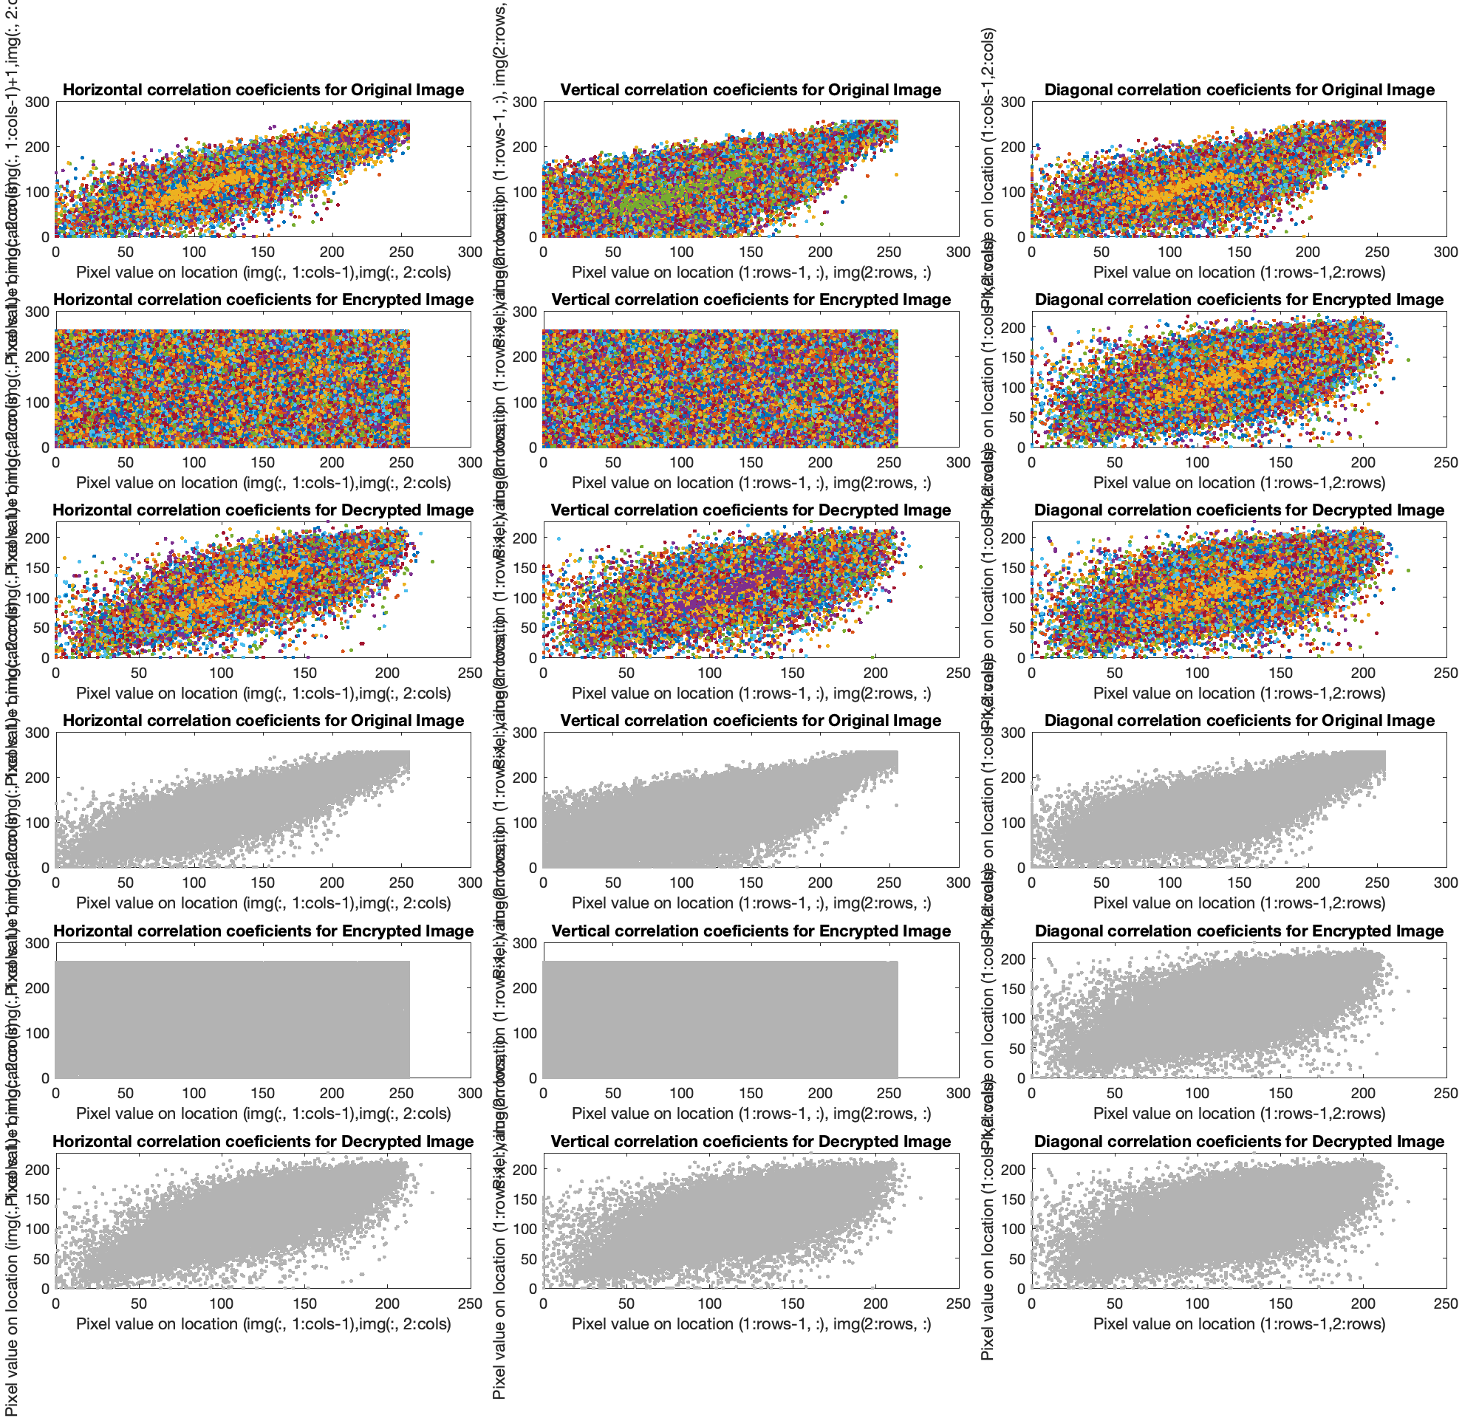

**Fig.8.3** The graphics of Horizontal, Vertical and Diagonal correlation coeficients for Original, Encrypted and Decrypted Picture: **Baboonn_256.jpg** in color map and grey map.

Also, the graphics of Horizontal, Vertical and Diagonal correlation coeficients for Original, Encrypted and Decrypted Picture: **Barbarra_256.jpg** in color map and grey map.

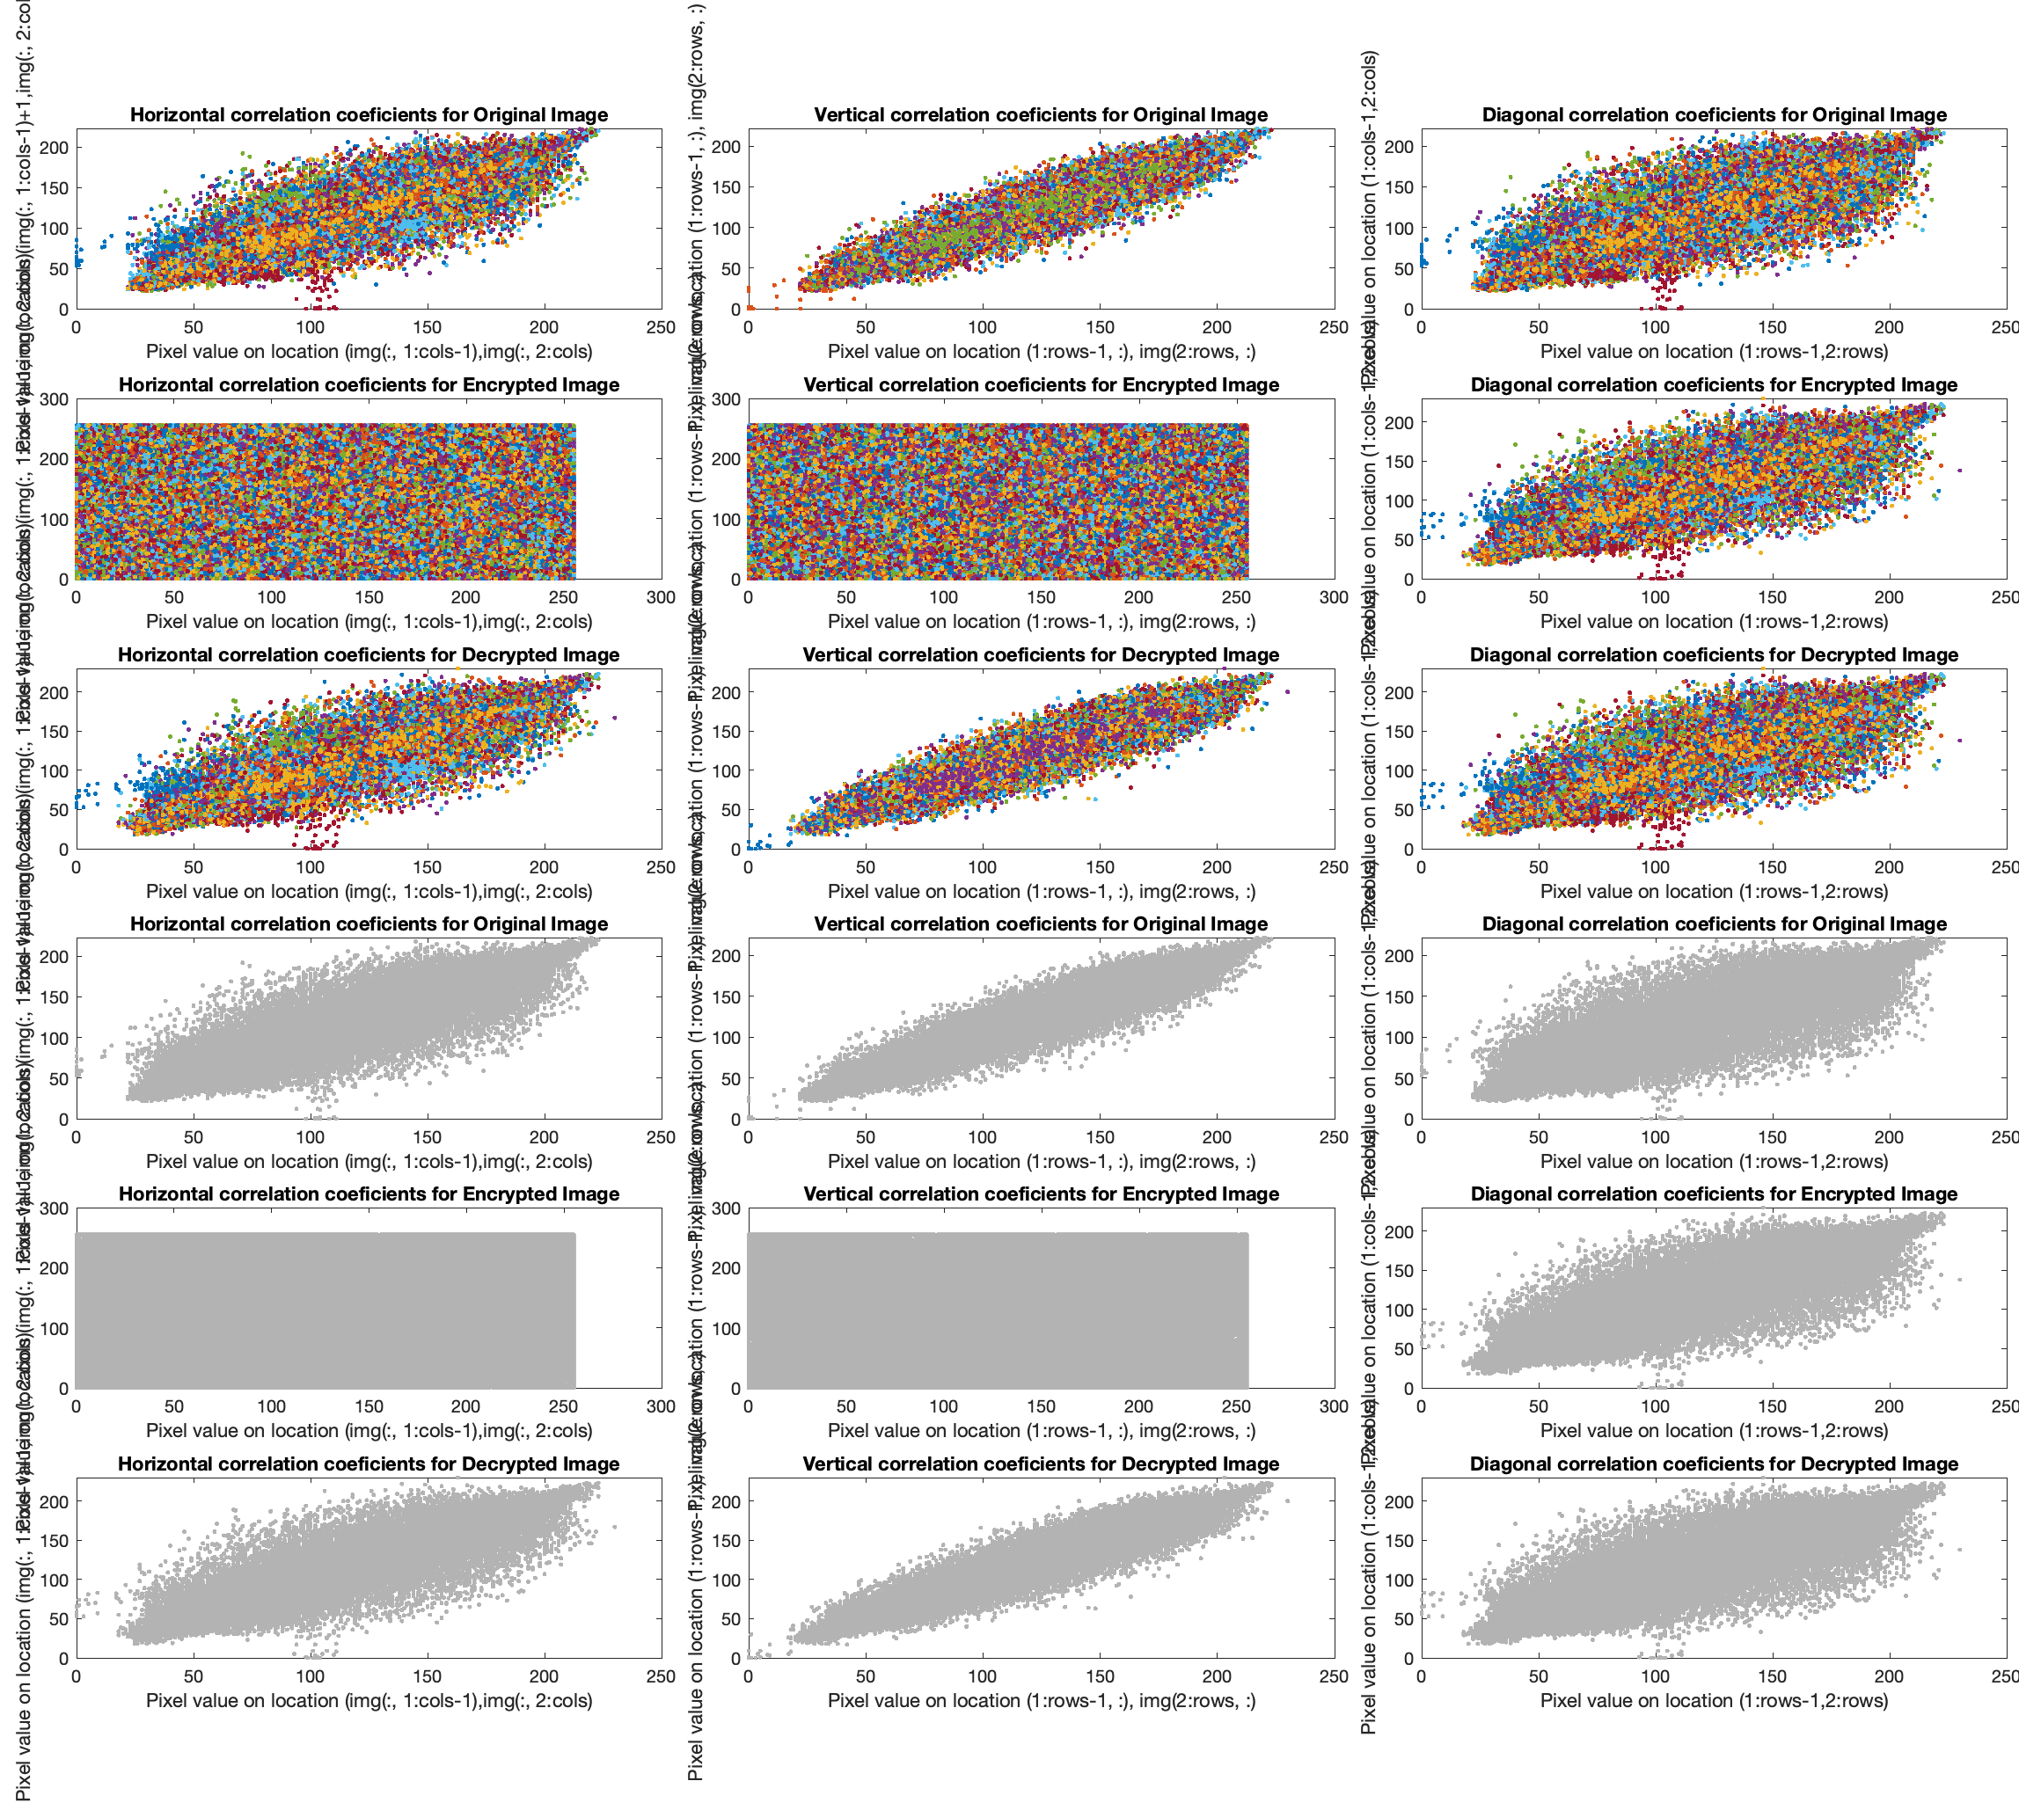

**Fig.8.4** The graphics of Horizontal, Vertical and Diagonal correlation coeficients for Original, Encrypted and Decrypted Picture: **Barbarra_256.jpg** in color map and grey map.

Also, the graphics of Horizontal, Vertical and Diagonal correlation coeficients for Original, Encrypted and Decrypted Picture: **Bonzzai_256.jpg** in color map and grey map.

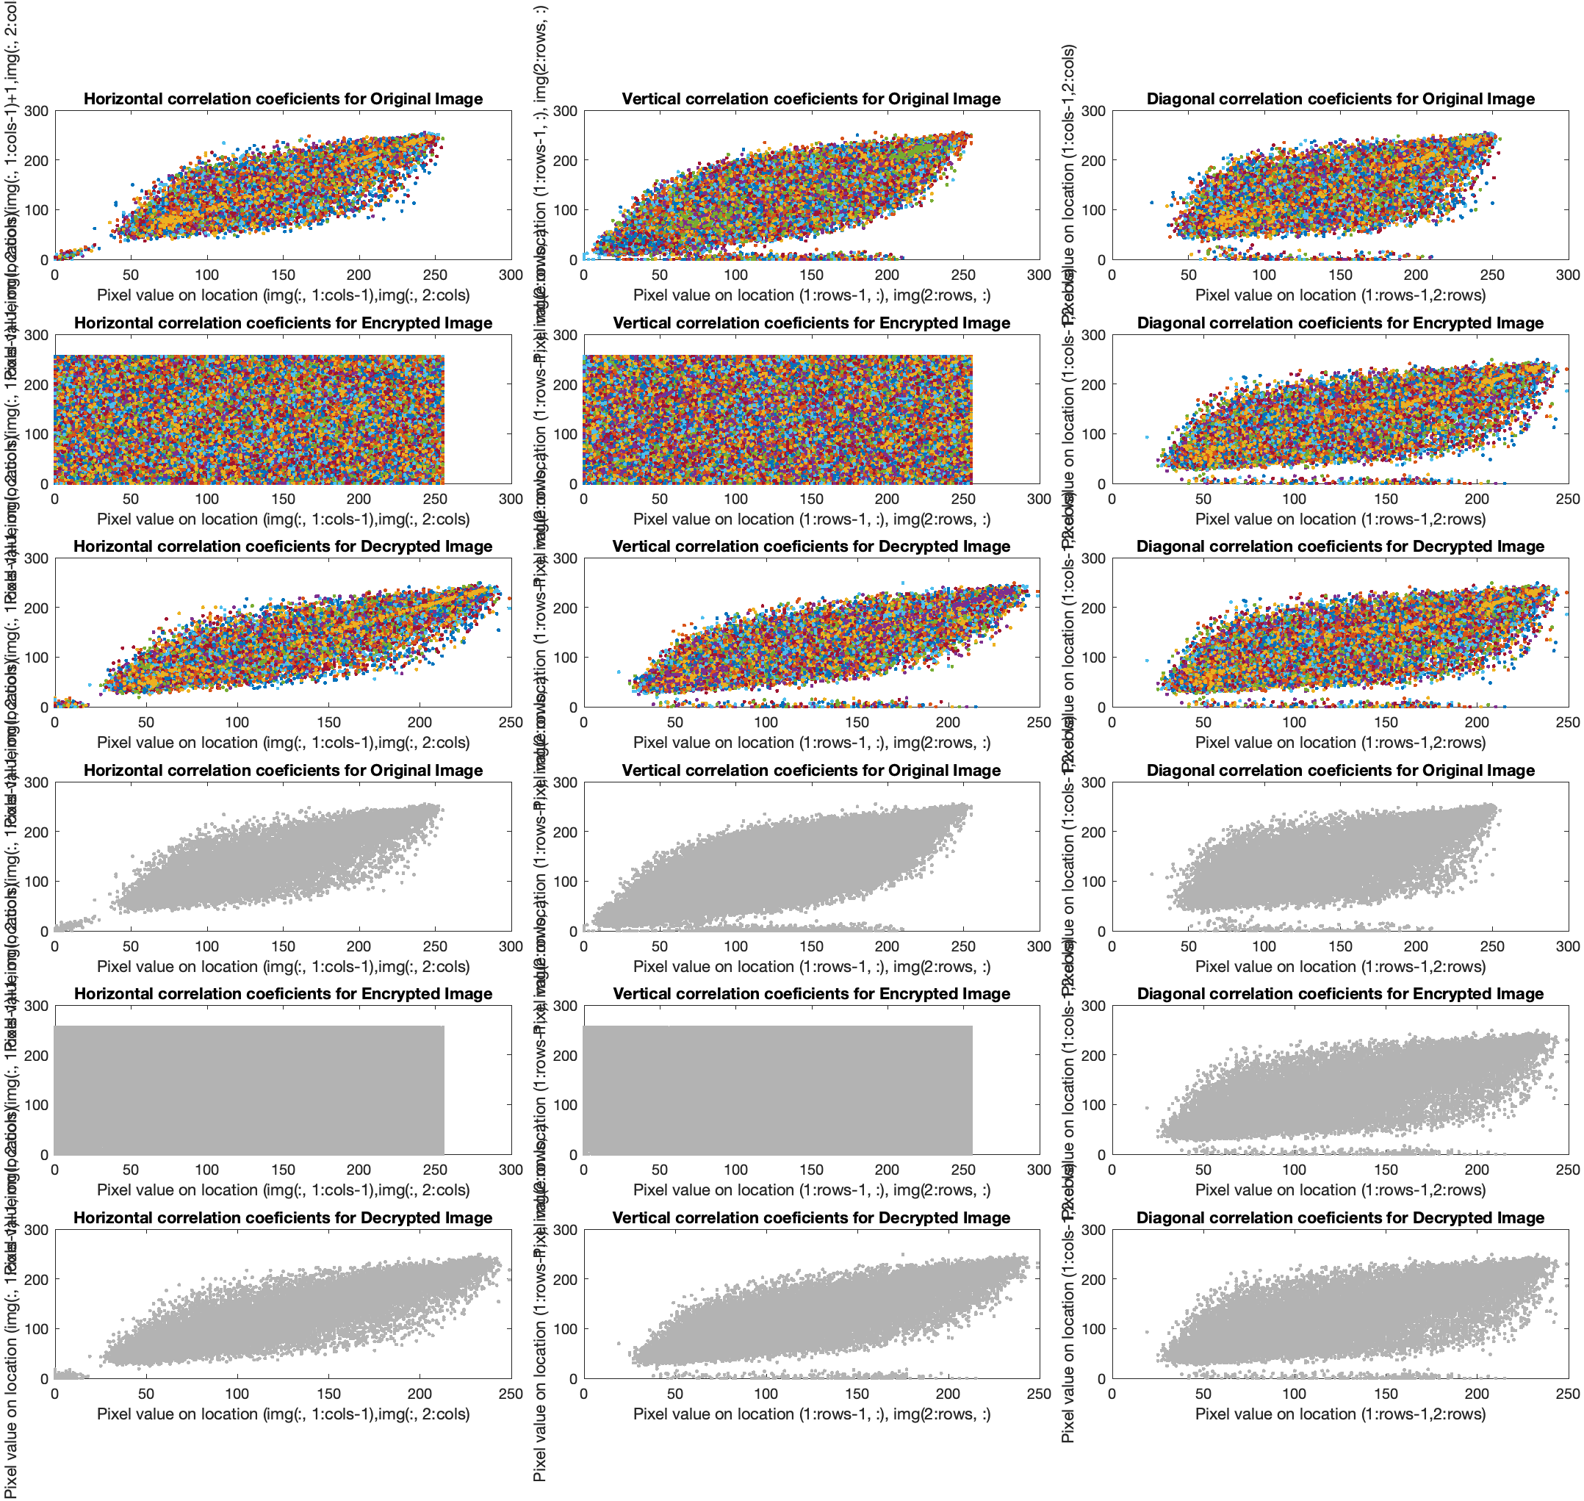

**Fig.8.5** The graphics of Horizontal, Vertical and Diagonal correlation coeficients for Original, Encrypted and Decrypted Picture: **Bonzzai_256.jpg** in color map and grey map.

Also, the graphics of Horizontal, Vertical and Diagonal correlation coeficients for Original, Encrypted and Decrypted Picture: **F16_256.jpg** in color map and grey map.

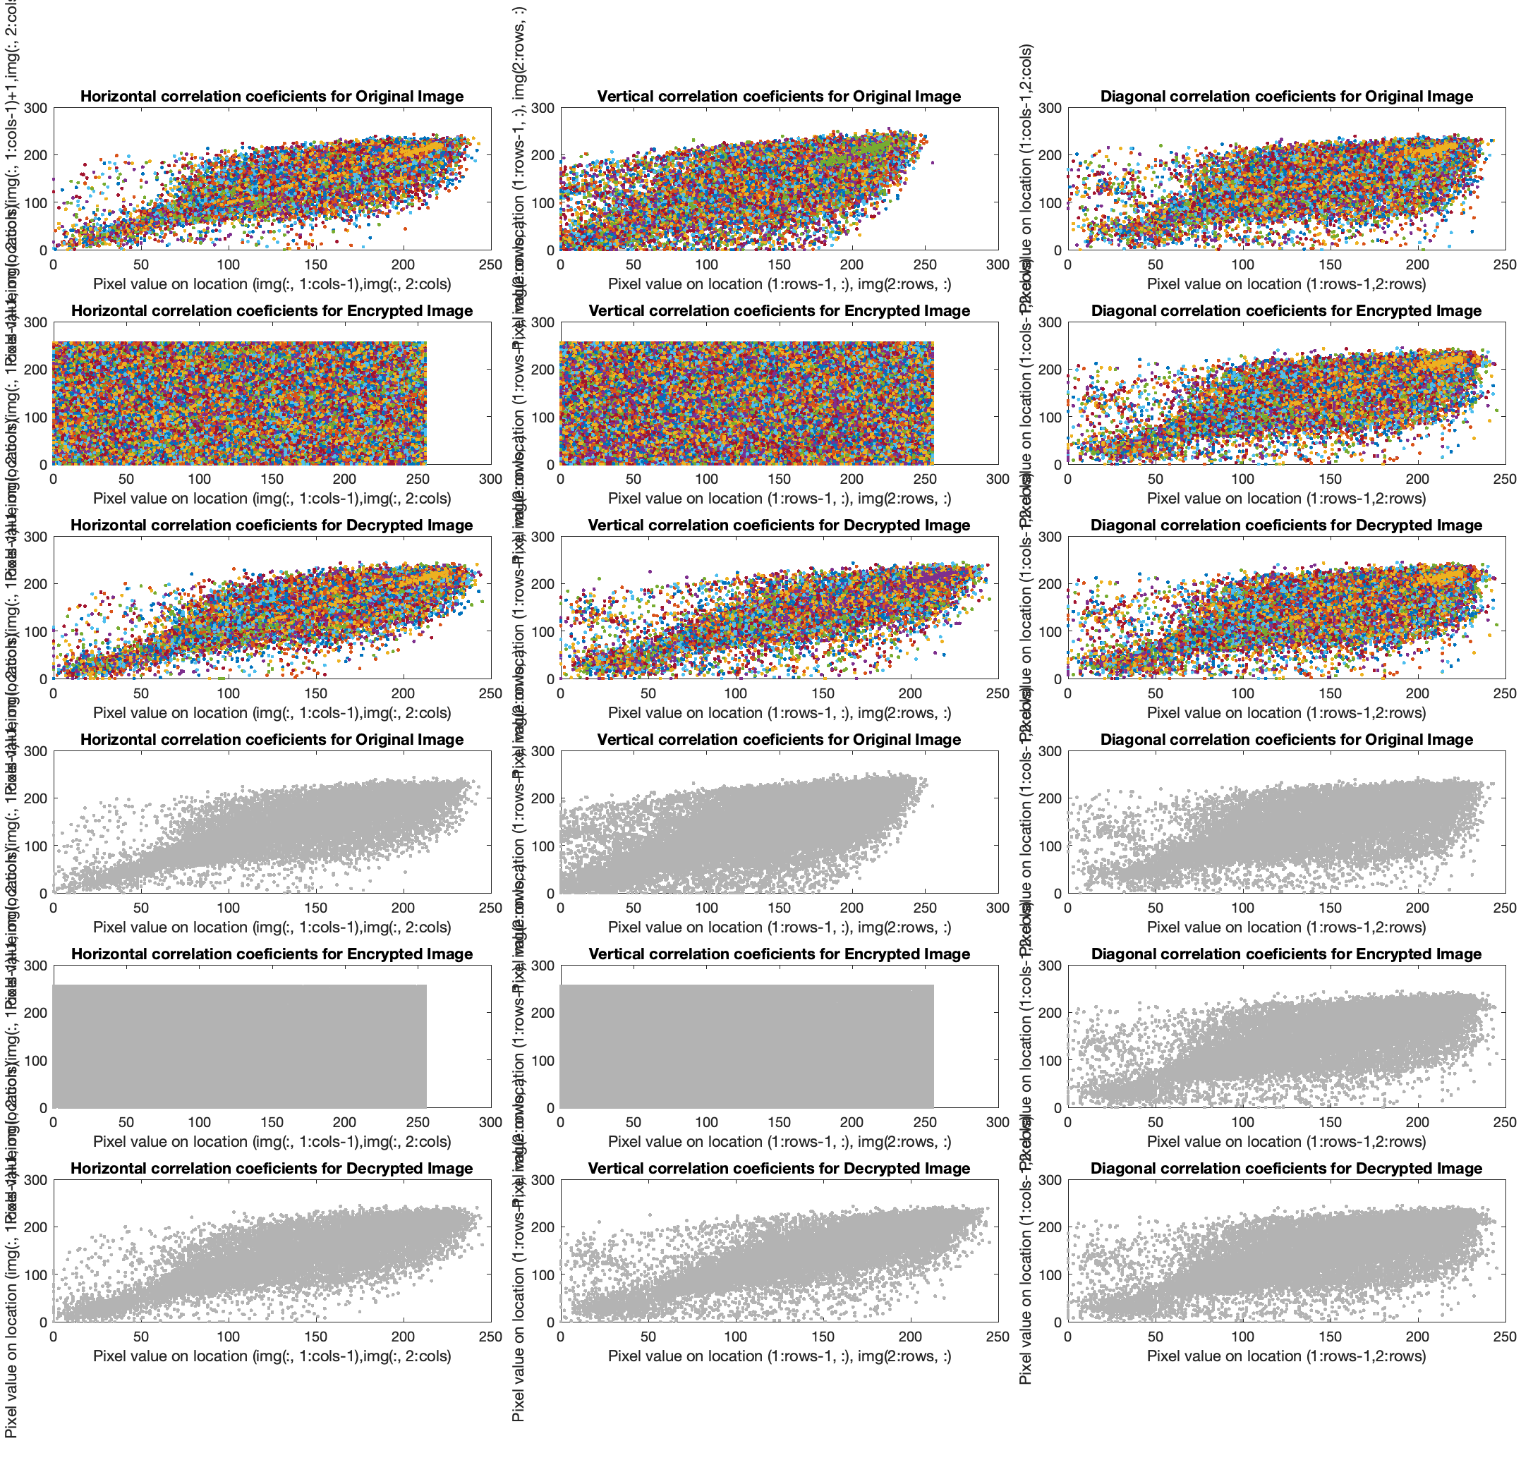

**Fig.8.6** The graphics of Horizontal, Vertical and Diagonal correlation coeficients for Original, Encrypted and Decrypted Picture: **F16_256.jpg** in color map and grey map.

Also, the graphics of Horizontal, Vertical and Diagonal correlation coeficients for Original, Encrypted and Decrypted Picture: **Lenn@_128.jpg** in color map and grey map.

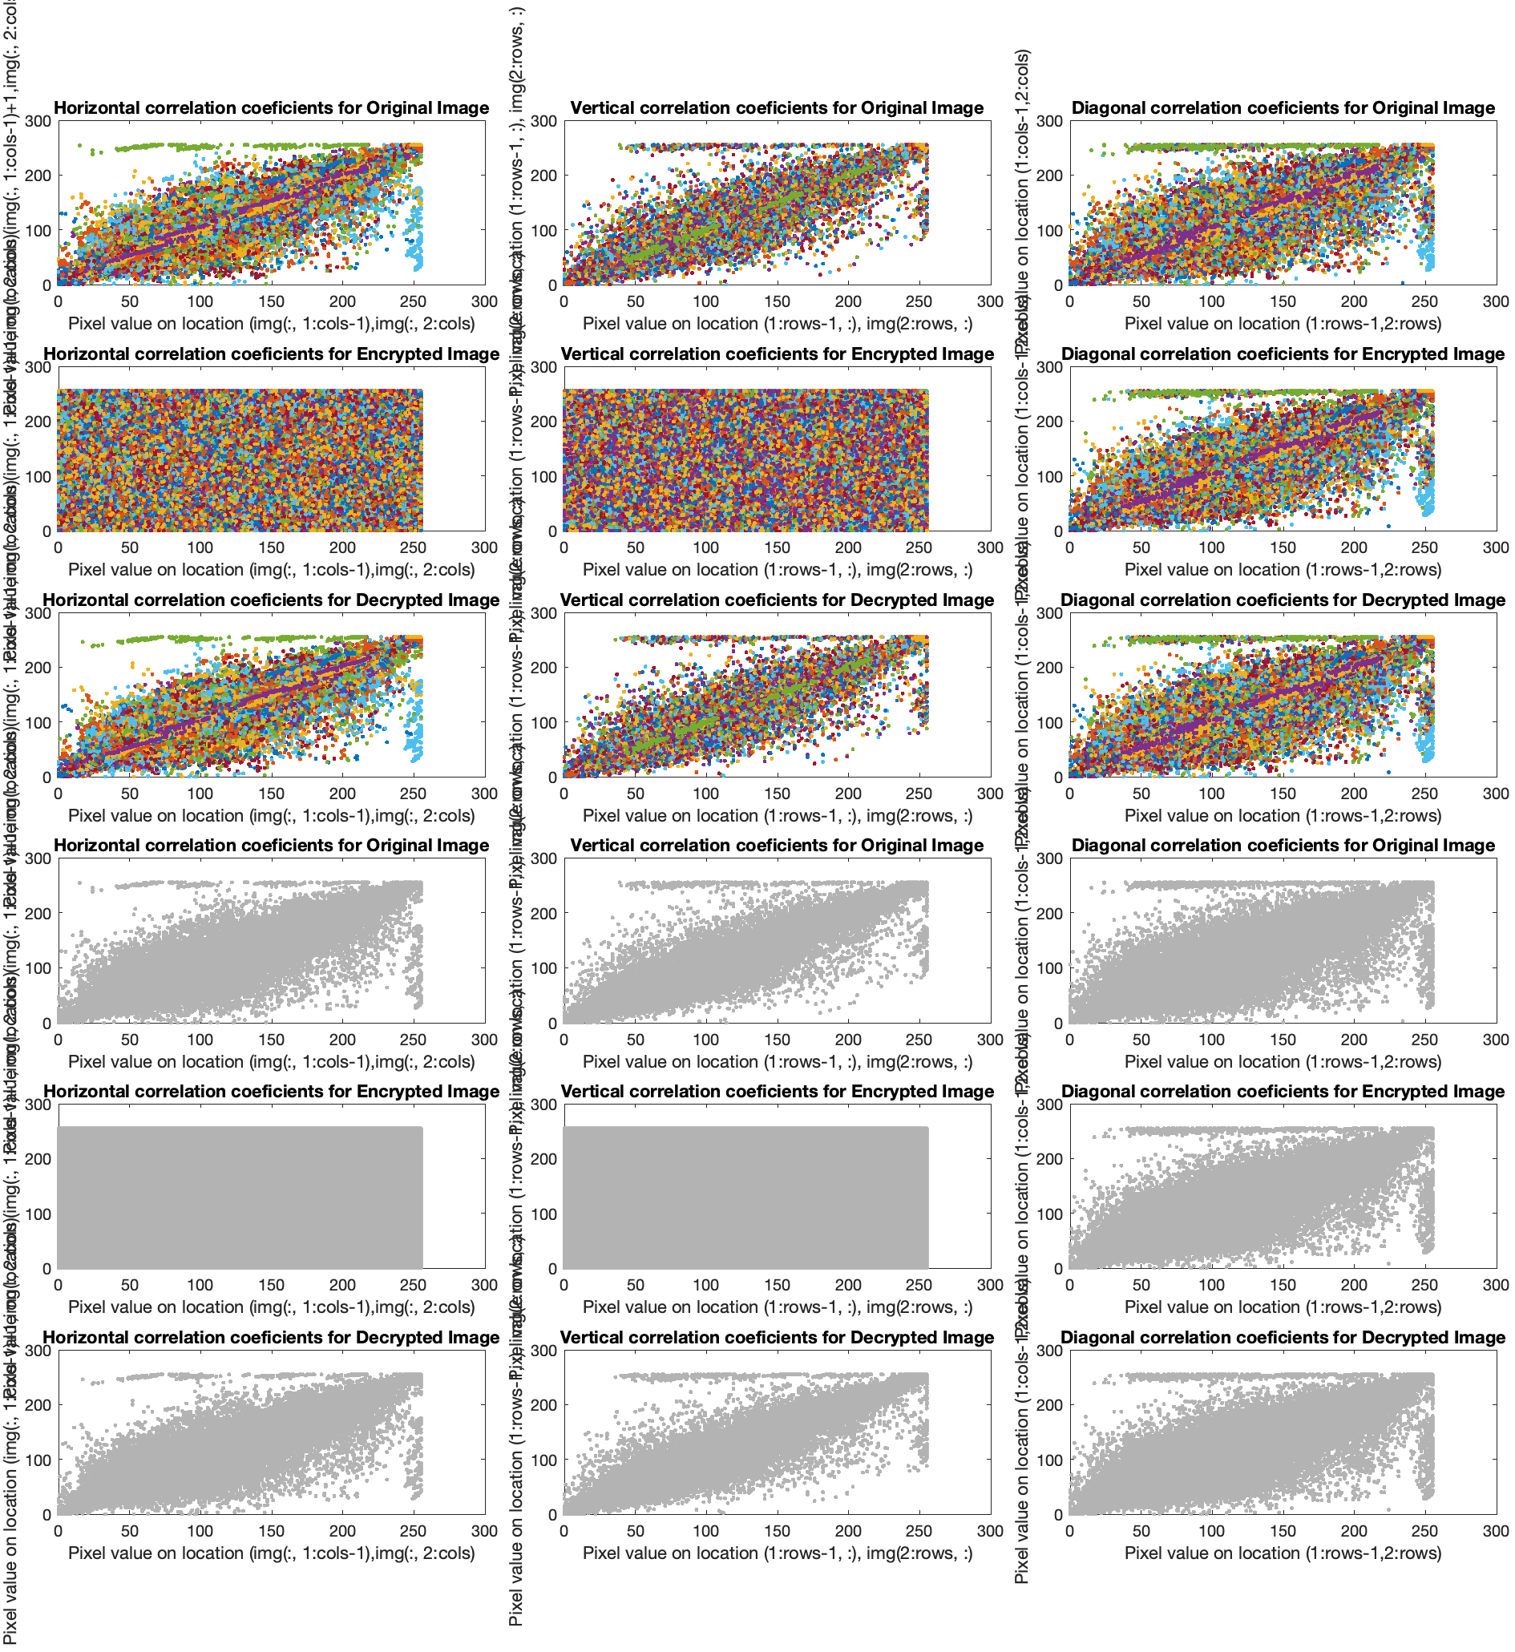

**Fig.8.7** the graphics of Horizontal, Vertical and Diagonal correlation coeficients for Original, Encrypted and Decrypted Picture: **Lenn@_128.jpg** in color map and grey map.

Also, the graphics of Horizontal, Vertical and Diagonal correlation coeficients for Original, Encrypted and Decrypted Picture: **Lenn@_256.png** in color map and grey map.

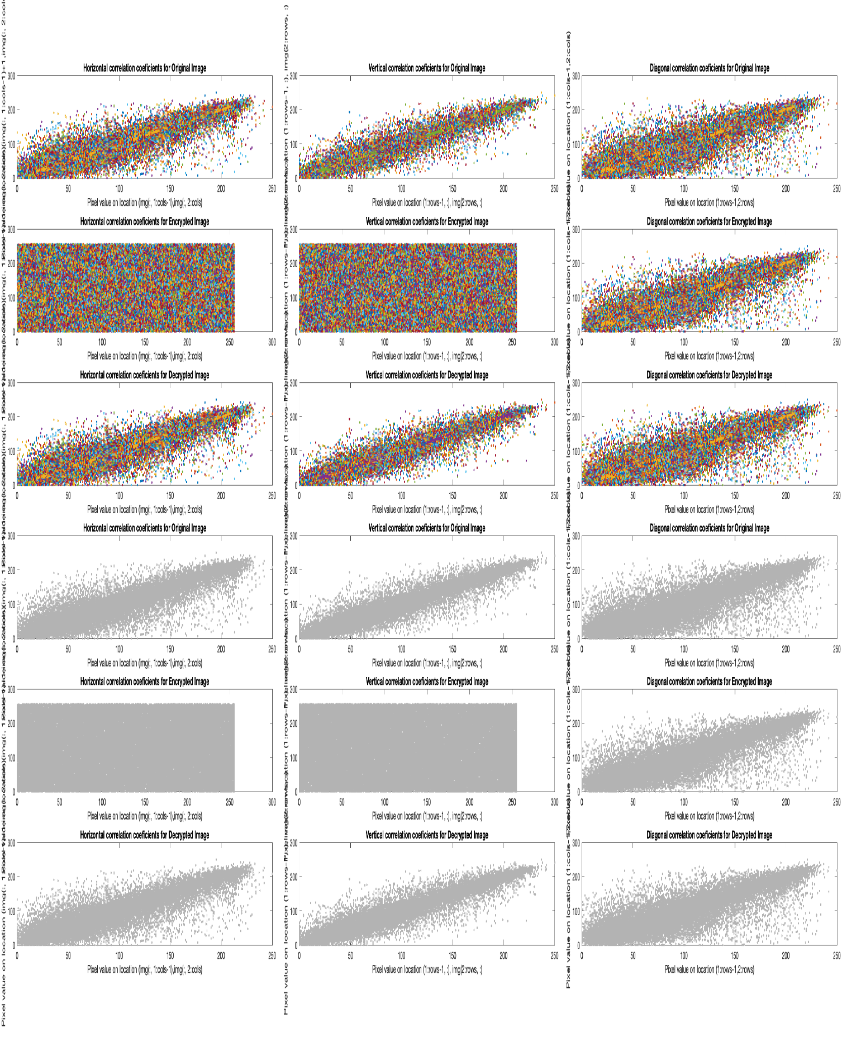

**Fig.8.8** The graphics of Horizontal, Vertical and Diagonal correlation coeficients for Original, Encrypted and Decrypted Picture: **Lenn@_256.png** in color map and grey map.

**Also, t**he graphics of Horizontal, Vertical and Diagonal correlation coeficients for Original, Encrypted and Decrypted Picture: **Lenn@_512.jpg** in color map and grey map.

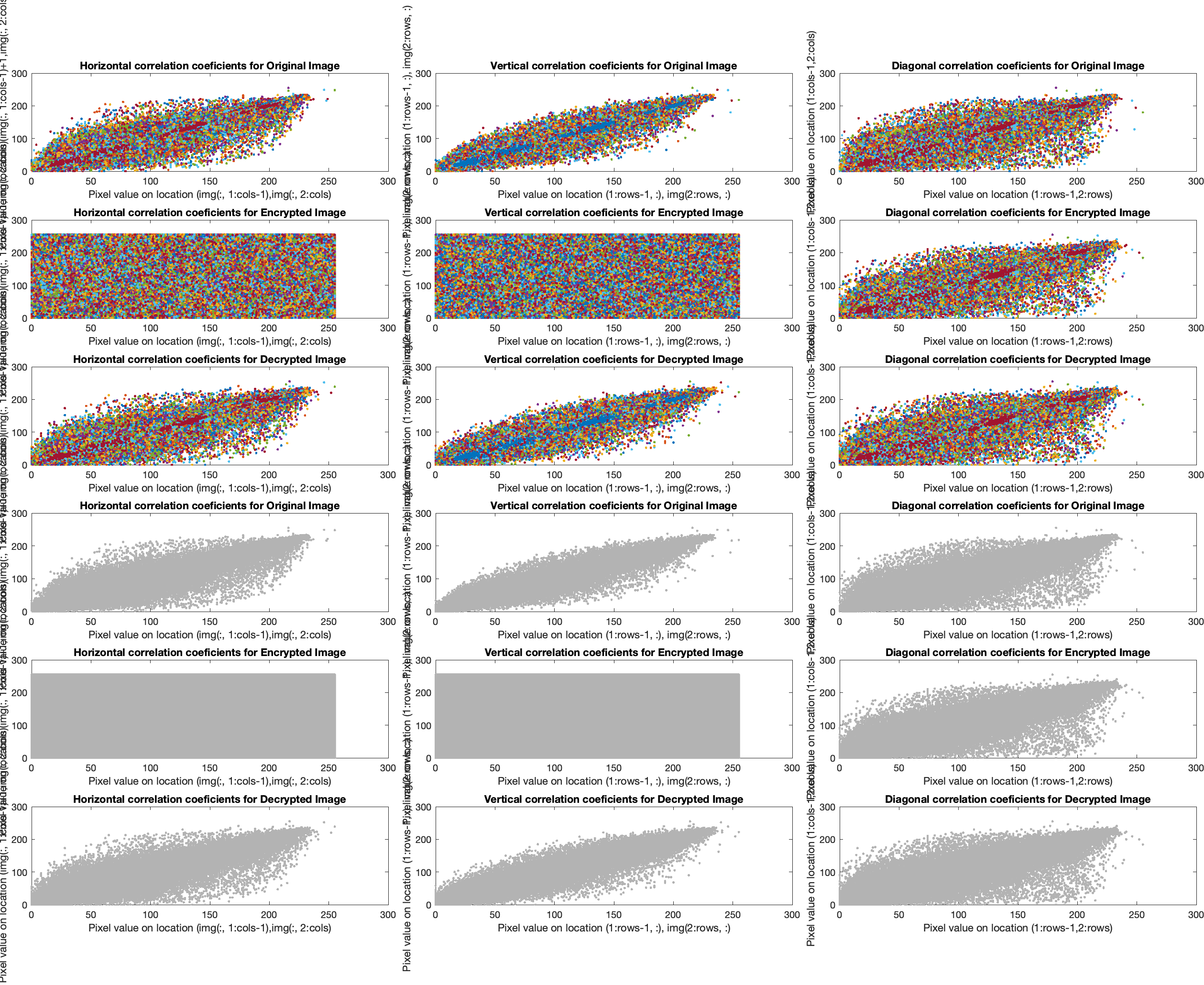

**Fig.8.9** The graphics of Horizontal, Vertical and Diagonal correlation coeficients for Original, Encrypted and Decrypted Picture: **Lenn@_512.jpg** in color map and grey map.

**Also, t**he graphics of Horizontal, Vertical and Diagonal correlation coeficients for Original, Encrypted and Decrypted Picture: **Lenn@_1024.png** in color map and grey map.

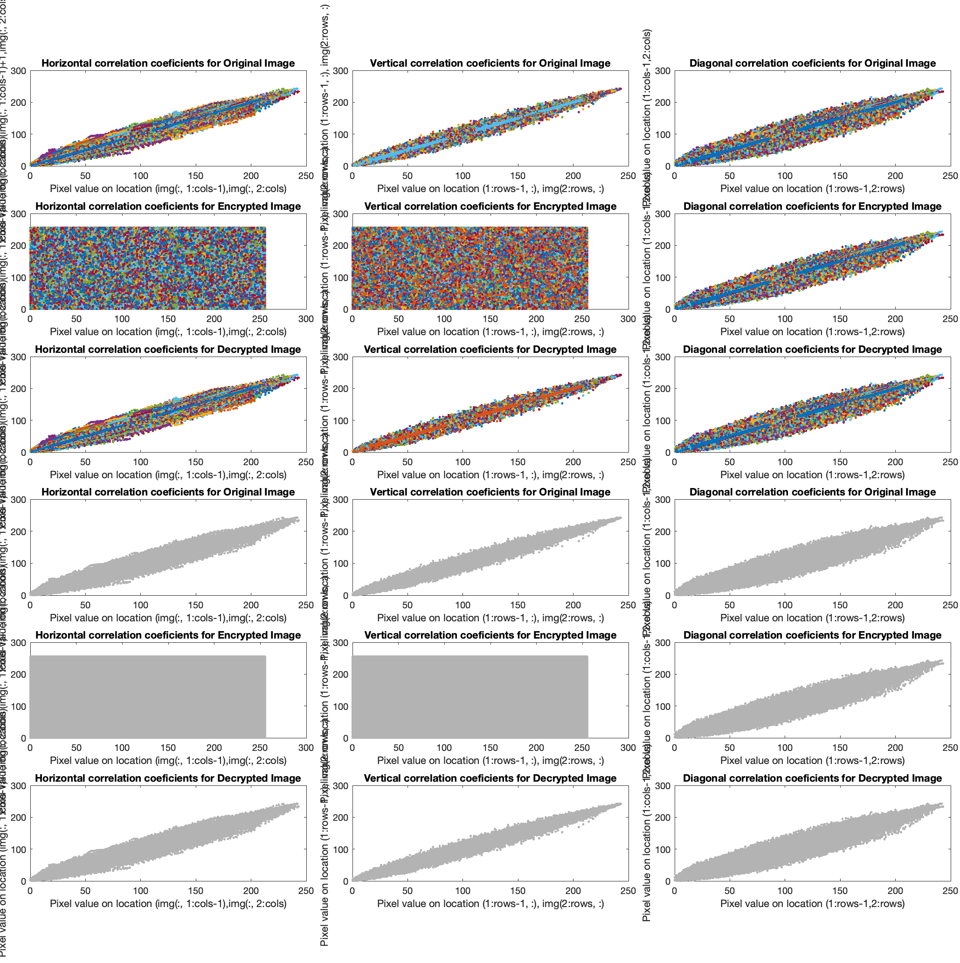

**Fig.8.10, t**he graphics of Horizontal, Vertical and Diagonal correlation coeficients for Original, Encrypted and Decrypted Picture: **Lenn@_1024.png** in color map and grey map.

**Also, t**he graphics of Horizontal, Vertical and Diagonal correlation coeficients for Original, Encrypted and Decrypted Picture: **Photographer_256.png** in color map and grey map.

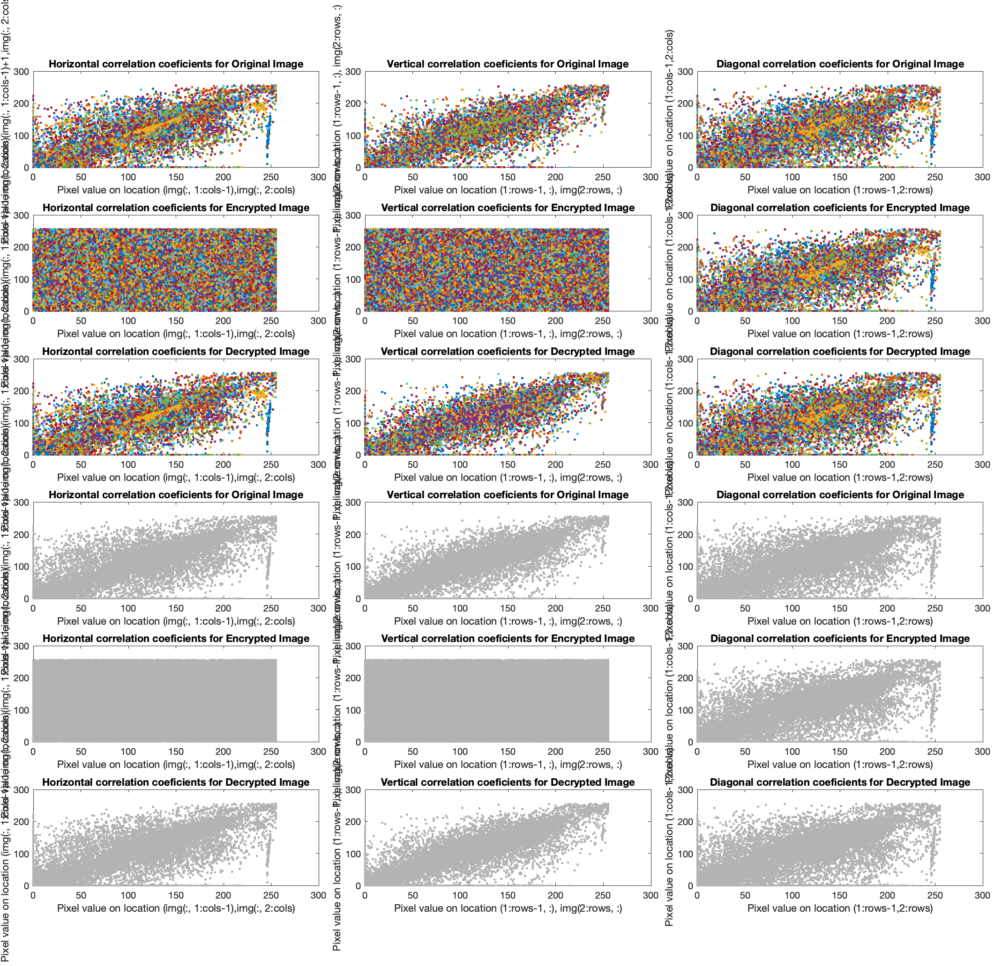

**Fig.8.11** The graphics of Horizontal, Vertical and Diagonal correlation coeficients for Original, Encrypted and Decrypted Picture: **Photographer_256.png** in color map and grey map.

Also, the graphics of Horizontal, Vertical and Diagonal correlation coeficients for Original, Encrypted and Decrypted Picture: **Watch_256.jpg** in color map and grey map.

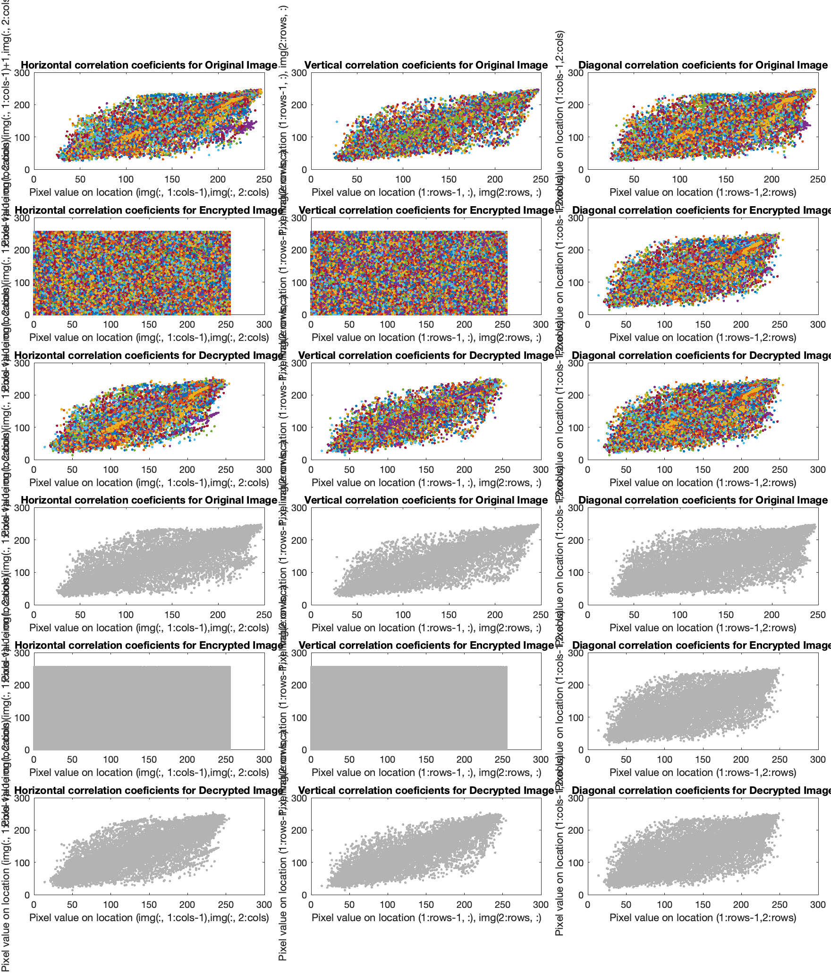

**Fig.8.12** The graphics of Horizontal, Vertical and Diagonal correlation coeficients for Original, Encrypted and Decrypted Picture: **Watch_256.jpg** in color map and grey map.

**In Fig. 8.13 The histograms of the (a) original and (b) encrypted pictures: Baboonn_256.jpeg**

**(a) original pictures**

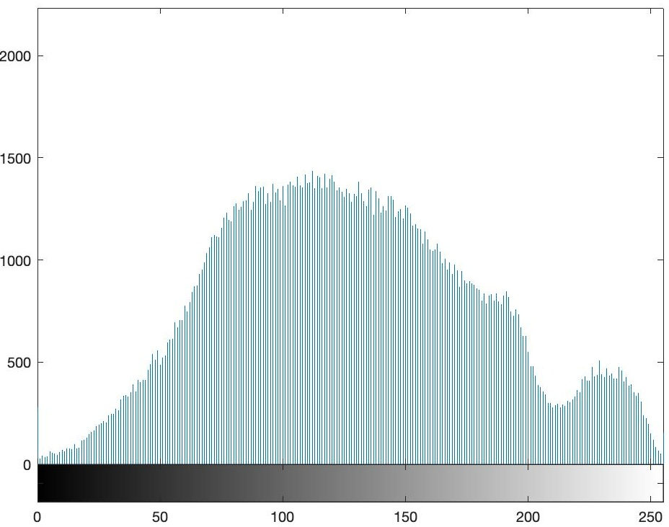

**Fig.8.13a X-Axis: "Pixel Intensity" and Y-Axis: "Frequency of Intensity"**

**(b) encrypted pictures**

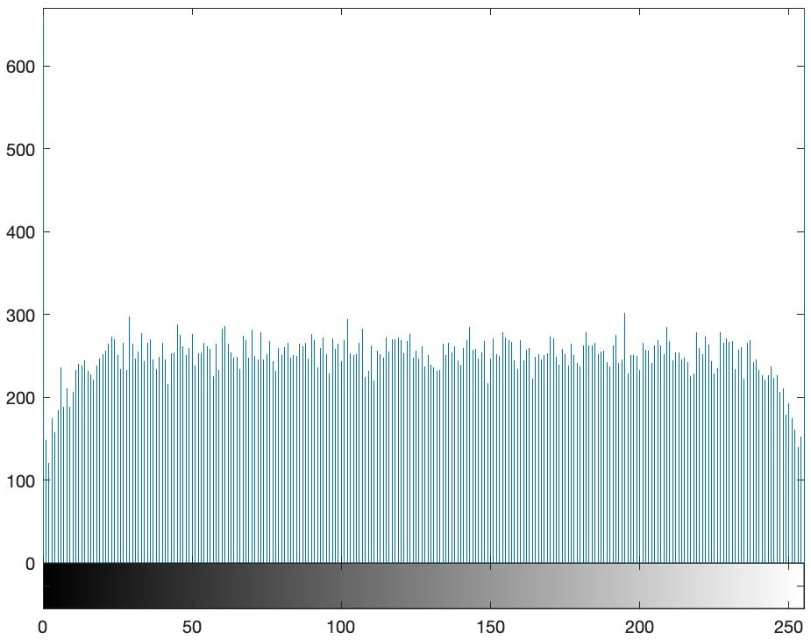

**Fig.8.13.b X-Axis: "Pixel Intensity" and Y-Axis: "Frequency of Intensity"**

**In Fig. 8.14 The histograms of the (a) original and (b) encrypted pictures: Barbarra_256.jpg**

**(a) original pictures**

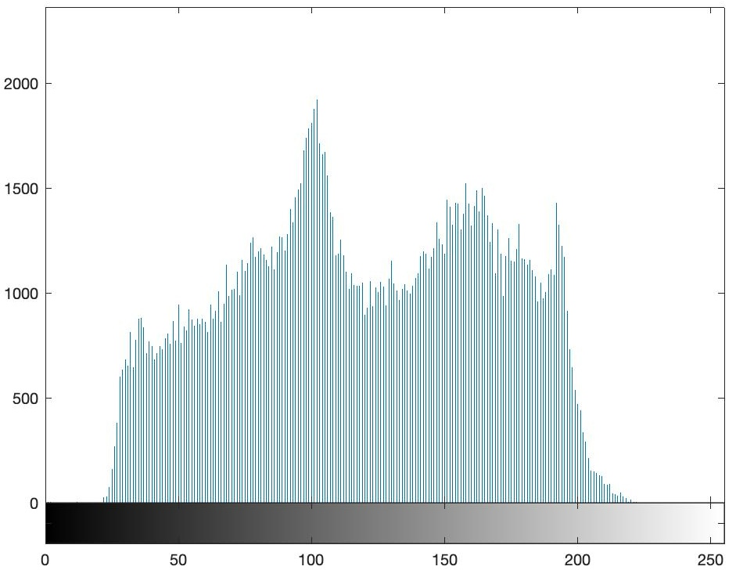

**Fig.8.14a X-Axis: "Pixel Intensity" and Y-Axis: "Frequency of Intensity"**

**b) encrypted pictures**

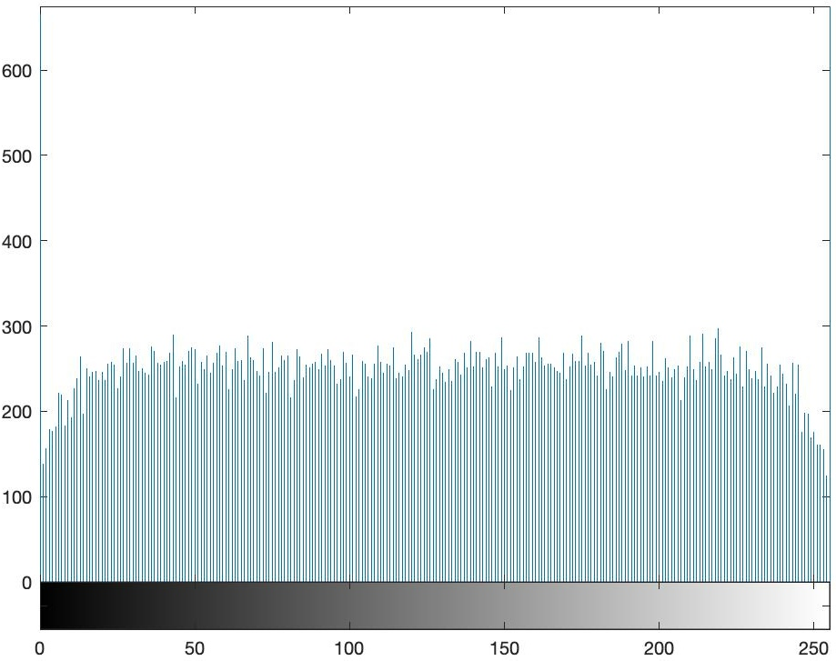

**Fig.8.14b X-Axis: "Pixel Intensity" and Y-Axis: "Frequency of Intensity"**

**In Fig. 8.15 The histograms of the (a) original and (b) encrypted pictures: F16_256.jpg**

**(a) original pictures**

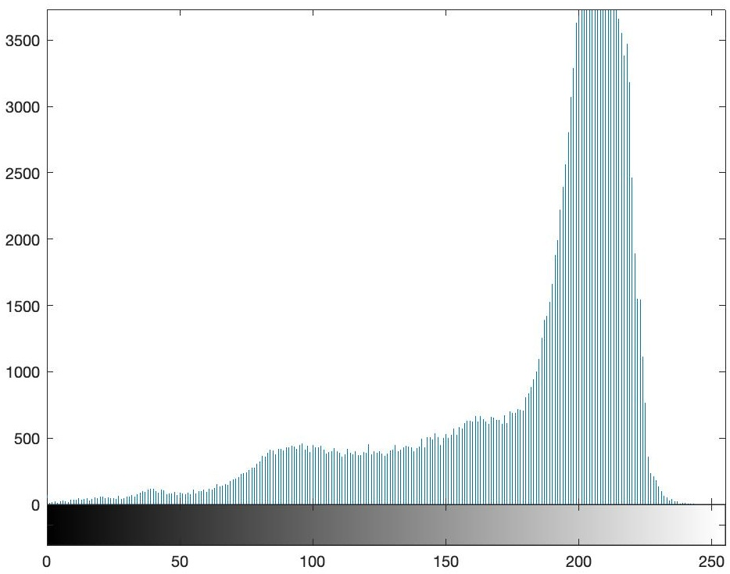

**Fig.8.15a X-Axis: "Pixel Intensity" and Y-Axis: "Frequency of Intensity"**

**b) encrypted pictures**

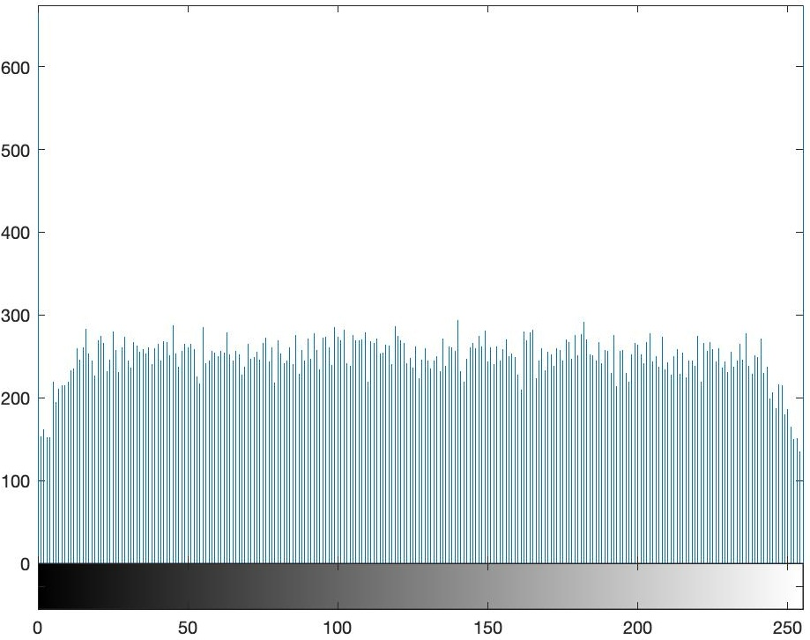

**Fig.8.15b X-Axis: "Pixel Intensity" and Y-Axis: "Frequency of Intensity"**

**In Fig. 8.16 The histograms of the (a) original and (b) encrypted pictures: Lenn@_128.jpg**

**(a) original pictures**

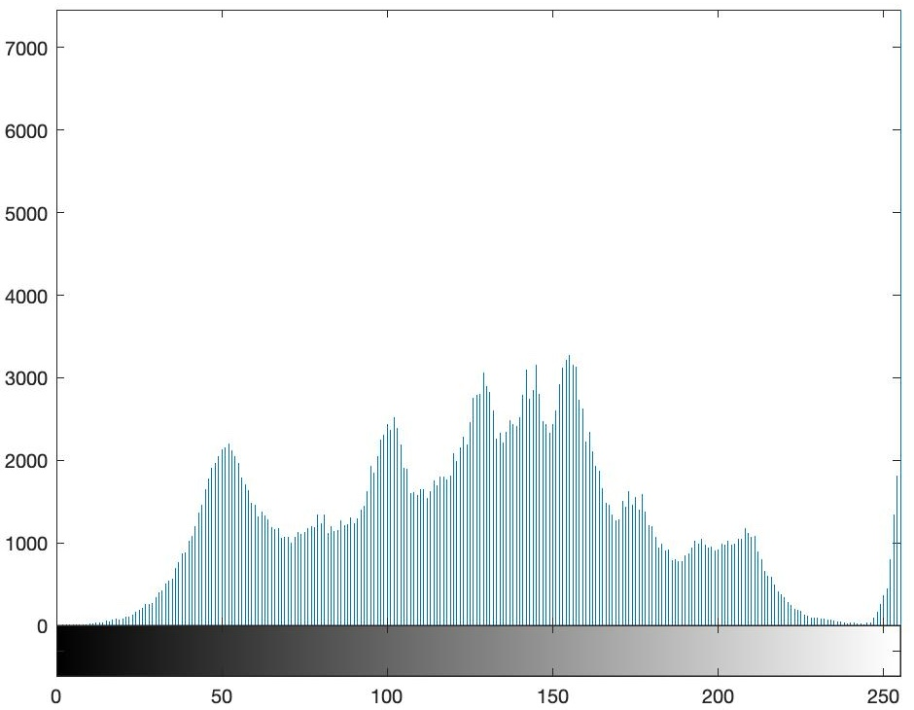

**Fig.8.16a X-Axis: "Pixel Intensity" and Y-Axis: "Frequency of Intensity"**

**b) encrypted pictures**

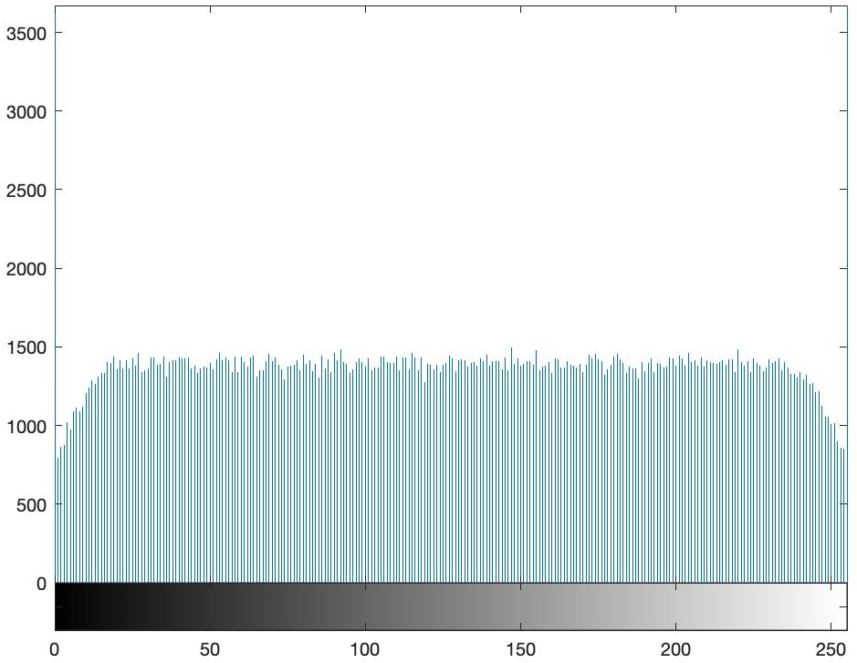

**Fig.8.16b X-Axis: "Pixel Intensity" and Y-Axis: "Frequency of Intensity"**

**In Fig. 8.17 The histograms of the (a) original and (b) encrypted pictures: Lenn@_256.png**

**(a) original pictures**

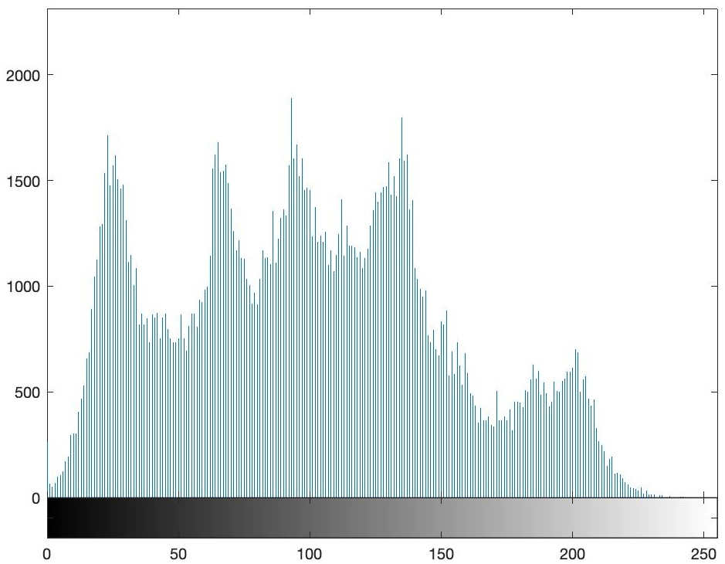

**Fig.8.17a X-Axis: "Pixel Intensity" and Y-Axis: "Frequency of Intensity"**

**b) encrypted pictures**

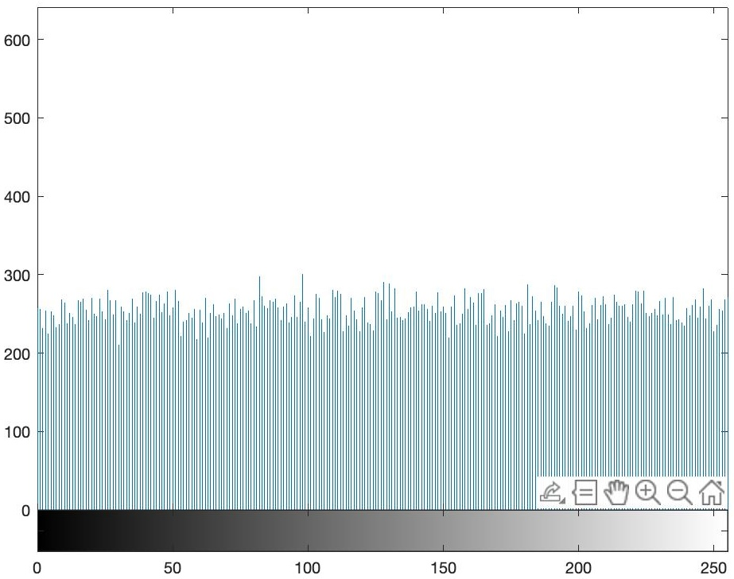

**Fig.8.17b X-Axis: "Pixel Intensity" and Y-Axis: "Frequency of Intensity"**

**In Fig. 8.18 The histograms of the (a) original and (b) encrypted pictures: Lenn@_512.jpg**

**(a) original pictures**

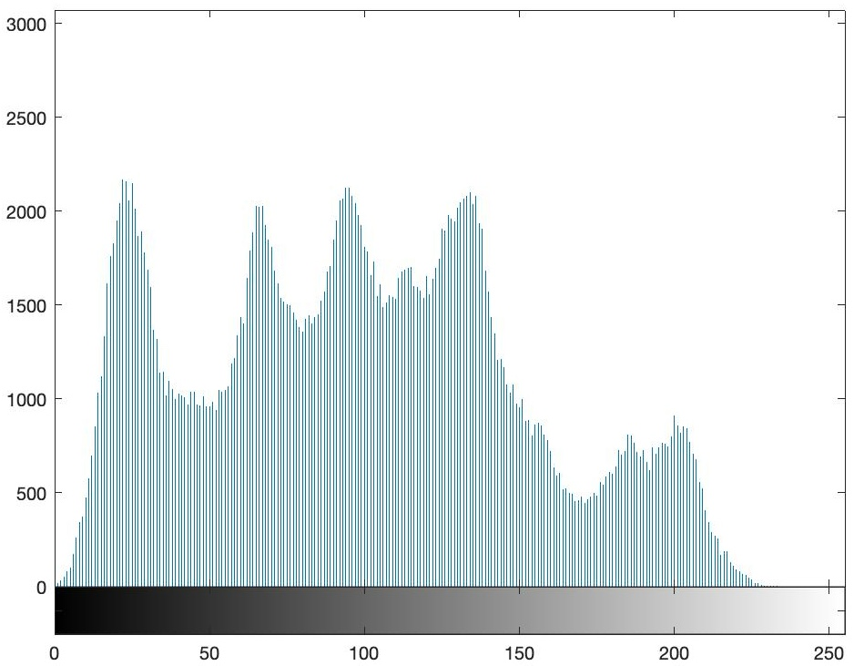

**Fig.8.18a X-Axis: "Pixel Intensity" and Y-Axis: "Frequency of Intensity"**

**b) encrypted pictures**

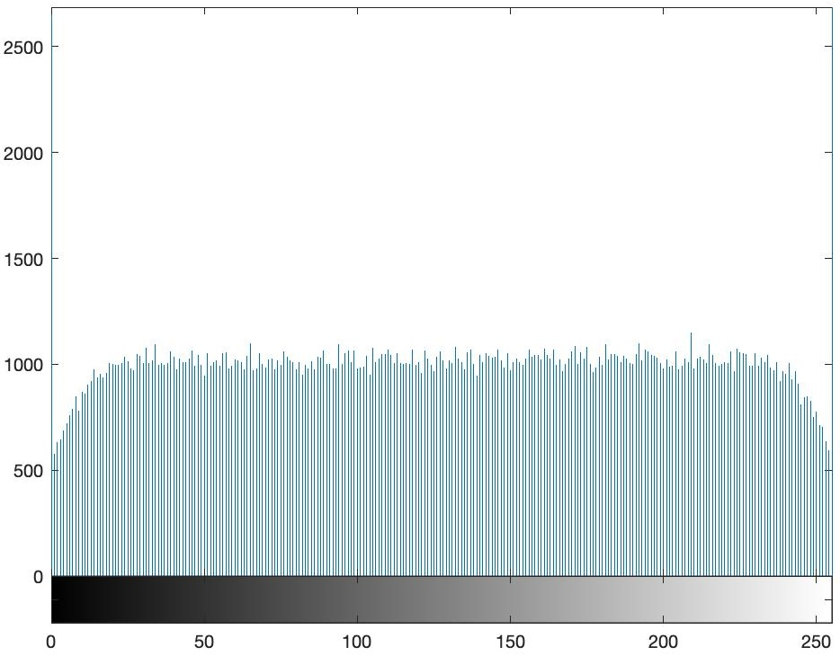

**Fig.8.18b X-Axis: "Pixel Intensity" and Y-Axis: "Frequency of Intensity"**

**In Fig. 8.19 The histograms of the (a) original and (b) encrypted pictures: Lenn@_1024**

**(a) original pictures**

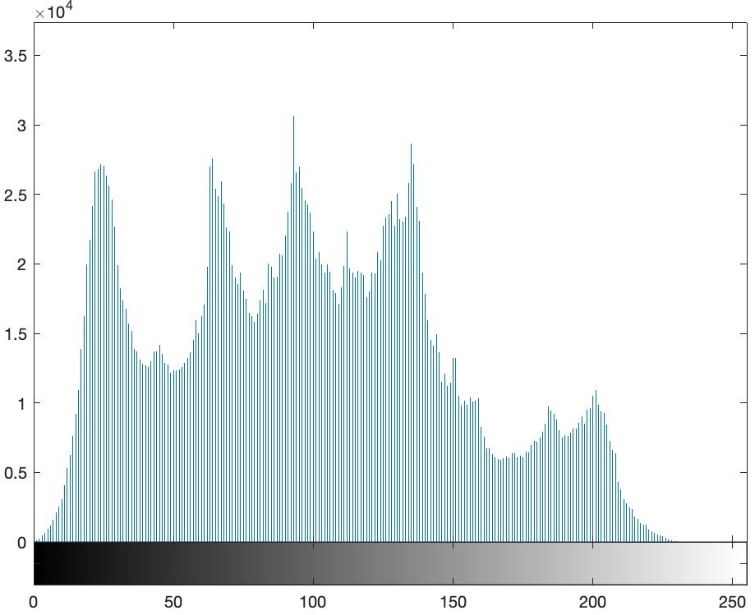

**Fig.8.19a X-Axis: "Pixel Intensity" and Y-Axis: "Frequency of Intensity"**

**b) encrypted pictures**

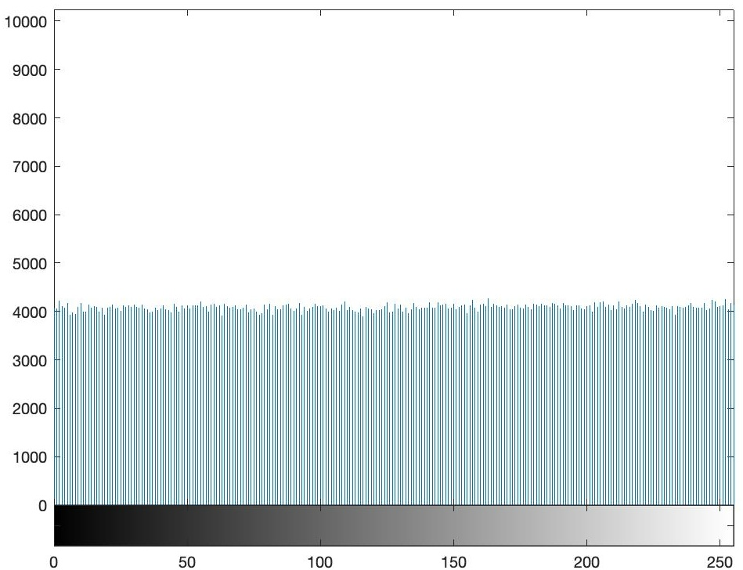

**Fig.8.19b X-Axis: "Pixel Intensity" and Y-Axis: "Frequency of Intensity"**

**In Fig. 8.20 The histograms of the (a) original and (b) encrypted pictures: Photographer_256.png**

**(a) original pictures**

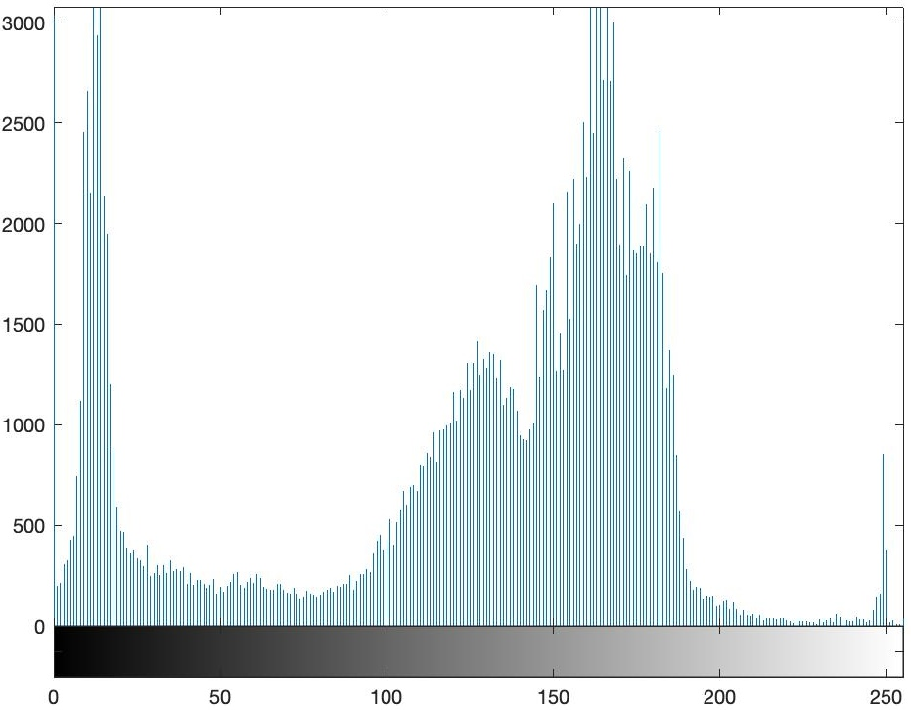

**Fig.8.20a X-Axis: "Pixel Intensity" and Y-Axis: "Frequency of Intensity"**

**b) encrypted pictures**

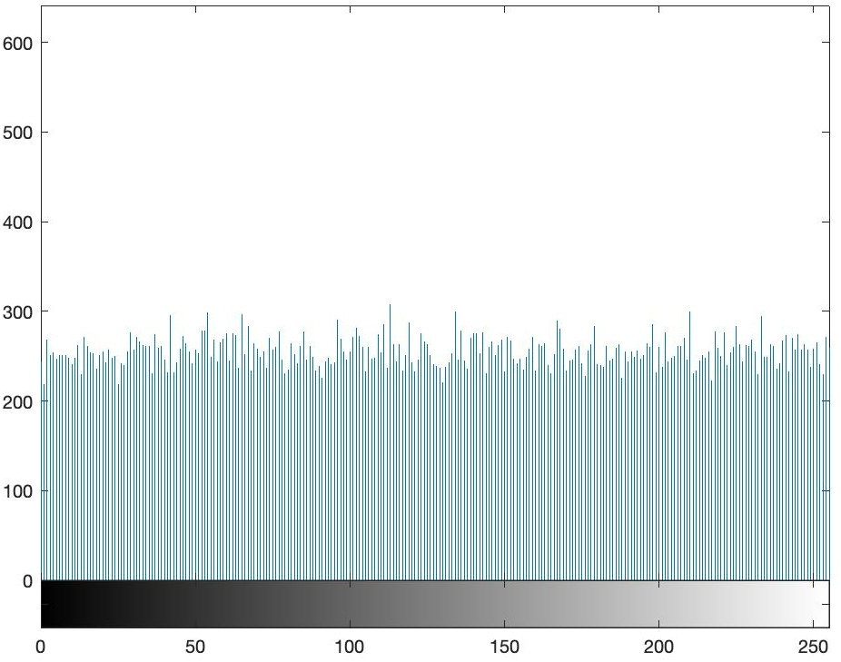

**Fig.8.20b X-Axis: "Pixel Intensity" and Y-Axis: "Frequency of Intensity"**

**In Fig. 8.21 The histograms of the (a) original and (b) encrypted pictures: Watch_256.jpg**

**(a) original pictures**

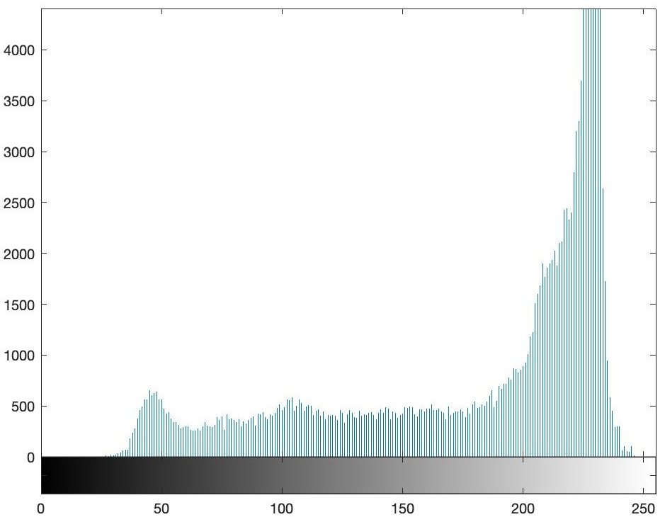

**Fig.8.21a X-Axis: "Pixel Intensity" and Y-Axis: "Frequency of Intensity"**

**b) encrypted pictures**

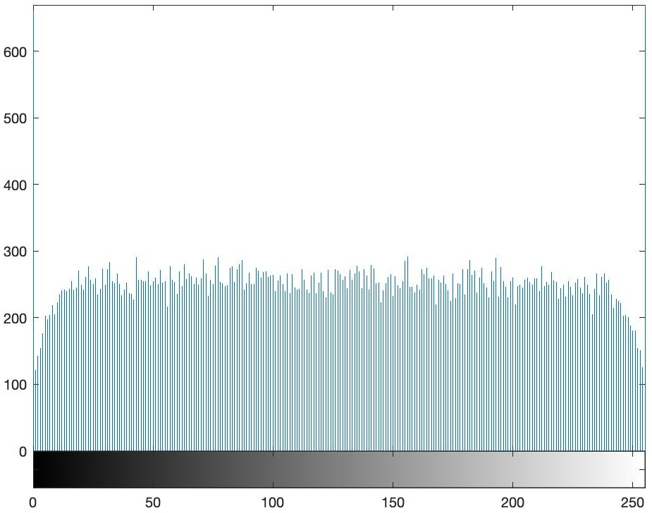

**Fig.8.21b X-Axis: "Pixel Intensity" and Y-Axis: "Frequency of Intensity"**

**In Fig. 8.22 The histograms of the (a) original and (b) encrypted pictures: Bonzzai_256_org**

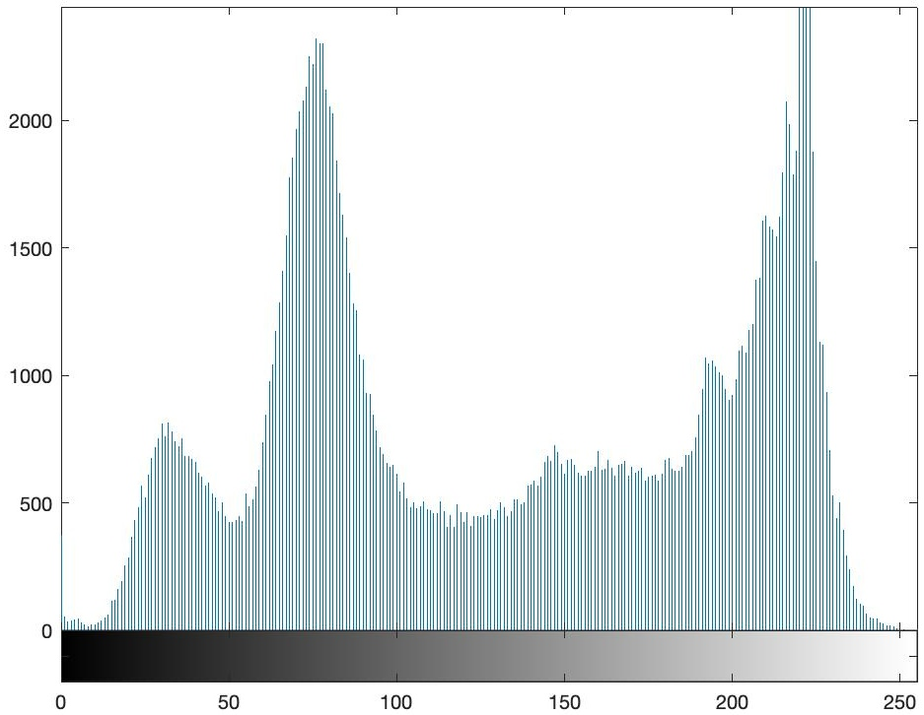

**Fig.8.22a X-Axis: "Pixel Intensity" and Y-Axis: "Frequency of Intensity"**

**b) encrypted pictures**

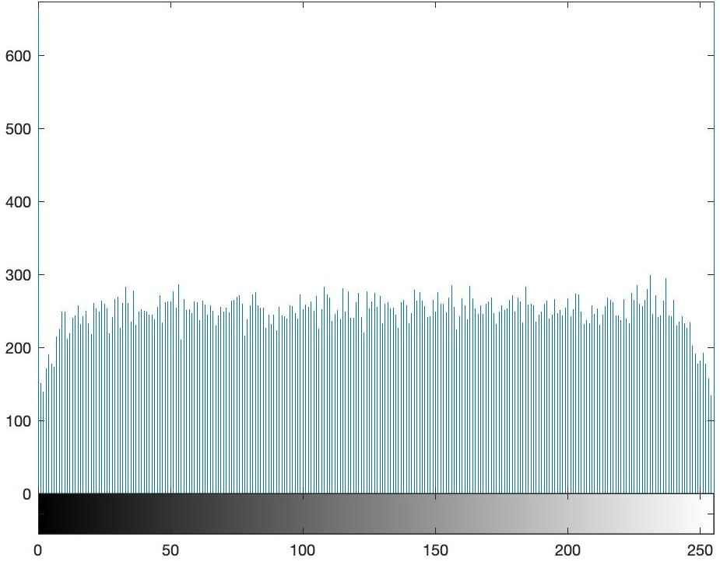

**Fig.8.22b X-Axis: "Pixel Intensity" and Y-Axis: "Frequency of Intensity"**

**Chapter 9**

**ANALYZE THE RESULTS**

The use of chaotic maps in image encryption, such as the Chebyshev map, Henon map, and logistic map, in image encryption algorithms provides a high degree of security due to their complex and unpredictable nature. They generate robust pseudorandom sequences that can effectively jam and hide image data, making unauthorized access without the correct key extremely difficult. By exploiting the inherent properties of chaos, these encryption techniques ensure that sensitive images remain protected, demonstrating the profound potential of chaotic systems in cryptography.

**9.1 Advantage:**

As a preliminary advantage, we may cite the security and effectiveness of chaotic systems. These systems are sensitive to initial conditions, which leads to highly unpredictable behavior. This inherent randomness increases the security of the encryption algorithm, as the encrypted image is very mixed and difficult to modify in reverse without the corresponding decryption key. Furthermore, the use of multiple chaotic maps increases the unpredictability and security of the encryption algorithm.

A second advantage is complexity, which is achieved by combining several chaotic systems. These chaotic systems allow the creation of complex encryption algorithms. By using the complicated dynamics of chaotic systems, encryption algorithms can be designed to provide a high level of complexity, making them resistant to various cryptographic attacks.

Another advantage is the speed of execution, as chaotic systems generate random number sequences rapidly, which can result in faster encryption processes compared to traditional encryption methods, particularly when working with large volumes of data such as high-resolution images or video streams.

Nonlinearity can be advantageous in that chaotic systems introduce nonlinearity into the encryption process, improving the confusion and diffusion properties of the encryption algorithm. This helps spread the influence of individual pixels across the entire encrypted image, making it more resistant to statistical attacks.

Finally, the use of parallelism can be considered an advantage. Chaotic systems are often well-suited to parallel computing architectures, which allows for the efficient implementation of encryption algorithms on parallel processing units. This results in improved encryption and decryption speeds, which are much faster.

**9.2  Disadvantages:**

A primary disadvantage is parameter sensitivity. Chaotic systems are highly sensitive to parameters and initial conditions, with minor alterations in these parameters resulting in significantly divergent chaotic trajectories. This can lead to challenges to the reproducibility and stability of the encryption algorithm.

A second disadvantage is key management. Chaotic system-based encryption algorithms typically necessitate the administration of intricate keys derived from chaotic sequences. The management and secure distribution of these keys can be complex, particularly in distributed systems or large-scale deployments.

Another disadvantage is the overhead. While chaotic systems offer advantages in terms of security and complexity, they can introduce a performance overhead compared to simpler encryption techniques. This is because the computational complexity of generating chaotic sequences and performing encryption operations can impact the speed and efficiency of the encryption process.

Limited analysis can be a disadvantage because chaotic systems are inherently difficult to analyze and predict due to their complex dynamics. However, this unpredictability is advantageous for encryption purposes. It can, however, make it difficult to thoroughly analyze and validate the security properties of the encryption algorithm.

Finally, we list test sensitivity in the sense that chaotic sequences used as encryption keys may exhibit sensitivity to initial conditions and parameters. This sensitivity could give rise to difficulties in key management, as minor variations in key generation processes could result in incompatible or less secure keys.

**9.3 Improvements:**

A first improvement would be to optimize the parameters by performing a deep and detailed analysis in which adaptive methods are implemented to select the optimal parameters for each chaotic map. This would enhance security and stability, especially in hybrid encryption, which combines chaotic encryption with traditional encryption techniques. This approach ensures a balance between security and performance, thereby providing stable and reproducible results.

The algorithm can be implemented in parallel using parallel computing architectures to improve speed and efficiency. A key management system can be developed to securely manage the distribution and storage of chaotic keys. A thorough security analysis can be performed to identify potential vulnerabilities and improve the robustness of the algorithm against attacks.

Further improvements can be made by employing more complex adaptive systems that are designed to dynamically adjust their parameters based on the characteristics of the image being encrypted. Additionally, a comprehensive analysis can be performed, which involves conducting analysis, testing, and thorough security validation of the encryption algorithm to ensure its robustness against different types of attacks.

A final improvement would be to combine these maps with two or three additional, more complex maps using multilevel cryptography keys, which would result in an optimization of the final algorithm for faster processing and the testing of the algorithm on a wider and more complex range of images.

By implementing these improvements, the algorithm can be more efficient, safer, and more practical for real-world applications**.**

**Chapter 10**

**CONCLUSIONS**

A preliminary conclusion can be drawn regarding the security and effectiveness of the algorithm. By employing chaotic systems for image encryption, the algorithm provides robust security due to the complex and unpredictable behavior of these systems, which ensures that the encrypted image is highly scrambled and difficult to modify backwards without the chosen decryption key successfully implementing an algorithm with combined encryption. This further increases the robustness and complexity of the encryption.

A second conclusion can be drawn from the analysis of performance metrics, including PSNR, entropy, NPCR, UACI, and pixel correlation. These metrics are essential for evaluating the efficiency of the algorithm. High values of entropy, NPCR, and UACI, in conjunction with low pixel correlation, indicate strong and random encryption of the encrypted image. This is evidenced by a high PSNR value between the original and decrypted image, which demonstrates that the decryption process accurately restores the original image.

In the event of successful implementation, it can be concluded that the algorithm runs without errors and produces an encrypted image and then a decrypted image that closely resembles the original image, thereby achieving good performance parameters. In this case, the algorithm can be considered a success.

In conclusion, testing the algorithm with different input images revealed consistent performance across different types of input data. The algorithm met the expected security and quality parameters and can be considered a reliable tool for secure and complex image encryption. This ensures the efficiency, robustness, and adaptability of the algorithm to different use cases.

**Chapter 11**

**REFERENCES**

[1] Mircea Raducanu, Corina Macovei (Nițu), Dominic-Gabriel Cheroiu, Fast Image Encryption Algorithm Based on Multiple Chaotic Maps, U.P.B, 978-1-6654-9485-4/22/$31.00 ©2022 IEEE

[2] O. Datcu, J.-P. Barbot, A. Vlad, New enciphering algorithm based on chaotic generalized H´enon map, Chaos Theory: Modeling, Simulation and Applications, Edited by Budyansky M V et al, Published by World Scientific Publishing Co. Pte. Ltd., 2011. ISBN 9789814350341, pp. 143-150, 2011, DOI: 0.1142/9789814350341 0016.

[3] X. Wang, and Z. Hongyu Zhao, Fast image encryption algorithm based on parallel permutation-and-diffusion strategy, Multimedia Tools and Applications, Vol. 79, issue 27-28, pp. 1-20, 2020.

[4] Analyzing Devaney Chaos of a Sine–Cosine Compound Function System Hegui Zhu∗, Wentao Qi†, Jiangxia Ge and Yuelin Liu, International Journal of Bifurcation and Chaos, Vol. 28, No. 14 (2018) 1850176 (13 pages) c World Scientific Publishing Company.

[5] An Algorithm for Image encryption based on chaotic maps, Herbadji Djamel , Herbadji Abdarrahmane, Ismail Haddad , Belmeguenaï Aïssa ,Nadir Derouiche , Hichem Kahia, 1st International Conference on Modern and Advanced Research, July 29-31, 2023 : Konya, Turkey, © 2023 Published by All Sciences Proceedings.

[6] https://scstrti.in/media/0iipkzxk/psnr-formula-in-image-processing

[7] https://www.mathworks.com/help/vision/ref/psnr.html

[8] A Secret Image Sharing Based on Logistic-Chebyshev Chaotic Map and Chinese , Remainder Theorem Asmaa Hilmi, Soufiane Mezroui, Ahmed El Oualkadi in Computer Science Journal of Moldova, vol.**31**, no.1(91), 2023

[9] IMAGE ANALYSIS:LABORATORY GUIDE, Constantin VERTAN, Mihai CIUC, Marta ZAMFIR, UPB-ETTI 2001.

[10] C.E. Shannon, “A mathematical theory of communication,” Bell System Technical Journal, vol. 27, pp. 379–423 and 623–656, 1948.

[11] R. Hobincu, O. Datcu, and C. Macovei, Entropy global control for a chaos based pRNG, 2019 42nd International Conference on Telecommunications and Signal Processing (TSP), pp. 432-435, 2019, IEEE.

[12] https://www.mathworks.com/help/images/ref/entropy.html

[13] https://www.mdpi.com/2227-7390/11/11/2585

A Parallel Encryption Algorithm Based on Piecewise Linear Chaotic Map XizhongWang and Deyun Chen, *School of Computer Science and Technology, Harbin University of Science and Technology, Harbin 150080, China*

[14] https://www.mdpi.com/2411-5134/8/4/102

[15] https://www.mathworks.com/help/stats/corr.html

[16] Sura F. Yousif, “Grayscale Image Confusion and Diffusion Based on Multiple Chaotic Maps,” in 1st International Scientific Con- ference of Engineering Sciences - 3rd Scientific Conference of En- gineering Science (ISCES), pp. 114–119, 2018.

[17] https://www.semanticscholar.org/paper/Image-Encryption-Scheme-Based-on-a-Generalized-Map-Jiao-Ye/ec76b772c49329e0148a77c6f5bed09cb1c66c89

[18] https://www.researchgate.net/profile/Zhengquan-Xu/publication/220405355_An_Improved_Image_Encryption_Algorithm_based_on_Chaotic_System/links/02e7e517fc4dda9d3e000000/An-Improved-Image-Encryption-Algorithm-based-on-Chaotic-System.pdf .

[19] https://www.mathworks.com/matlabcentral/answers/506464-getting-a-nan-in-correlation-coefficient

[20] A Parallel Encryption Algorithm Based on Piecewise Linear Chaotic Map XizhongWang and Deyun Chen, *School of Computer Science and Technology, Harbin University of Science and Technology, Harbin 150080, China*

[21] https://onlinelibrary.wiley.com/doi/10.1155/2013/537934

[22]https://www.researchgate.net/publication/235966571_A_novel_image_encryption_based_on_hash_function_with_only_two-round_diffusion_process

[23] An Image Encryption Algorithm Based on Balanced Pixel and Chaotic Map Jian Zhang and Yutong Zhang College of Information and Computer Engineering, Northeast Forestry University, Harbin 150040, China.

[24] An Image Encryption Scheme Based on Lorenz Hyperchaotic System and RSA Algorithm

Riguang Lin and Sheng Li Faculty of Mathematics and Computer Science, Guangdong Ocean University, Zhanjiang 524088, China

25] A Color Image Encryption Scheme Based on a Novel 3D Chaotic Mapping Chunyuan Liu1,2 and Qun Ding 1 1Electronic Engineering College, Heilongjiang University, Harbin 150080, China

[13] S. Farwa, T. Shahy, N. Muhammad, N. Bibiz, A. Jahangir, S. Arshadyet al.,“An image encryption technique based on chaotic S-box and Arnold transformapplications,” Int. J. Adv. Comput. Sci. Appl.8(5), 360–264 (2017).

[26] M. Kanaf, B. Fathiet al., “A novel image encryption scheme based on Clif-ford attractor and noisy logistic map for secure transferring images in navy,” Int.J. e-Navigation Marit. Econ.6(21), 53–63 (2017).

[27] Z. Hua, Y. Zhou, C.-M. Pun, C. L. Philip Chenet al., “2D Sine Logistic modulation map for image encryption,” Inf. Sci. J.297(15), 80–94 (2015).

[28] X. Wang, X. Zhu, Y. Zhanget al., “An image encryption algorithm based on Josephus traversing and mixed chaotic map,” IEEE Access6(14), 23733–23746(2018).

[29] X. Liu, D. Xiao, Y. Xianget al., “Quantum image encryption using intra andinter bit permutation based on logistic map,” IEEE Access7(10), 6937–6946(2018).

[30] T. Gopalakrishnan, S. Ramakrishnanet al., “Image encryption in block-wisewith multiple chaotic maps for permutation and diffusion,” ICTACT J. ImageVideo Process.6(8), 1220–1227 (2016).

[31] X. Wu, B. Zhu, Y. Hu, Y. Ranet al., “A novel color image encryption schemeusing rectangular transform-enhanced chaotic tent maps,” IEEE Access5(8), 1(2017).

[32] C. Zhu, K. Sunet al., “Cryptanalyzing and improving a novel color imageencryption algorithm using RT-enhanced chaotic tent maps,” IEEE Access6(12),18759–18770 (2018).

[33] Yousif, B., Khalifa, F., Makram, A., & Takieldeen, A. (2020). A novel image encryption/decryption scheme based on integrating multiple chaotic maps. AIP Advances, 10(7), 075220.

**Appendix_1**

**THE MATLAB CODE**

% Image encryption algorithm with 3 chaotic systems: the Chebyshev map, the Henon map and the Logistic map

% Created by POPESCU VLAD GABRIEL 441G_dif_UPB_ETTI_TSTen_©2024

org_pict = imread('Lena_256.png');

figure('Name','Fig.1: Original Picture: Lena_256'); imshow(org_pict),

% Step 2: Convert to grayscale if it's a color image and Normalize the

% picture

if size(org_pict, 3) == 3

org_pict = rgb2gray(org_pict);

end

% Normalize the picture

org_pict = double(org_pict);

imwrite(uint8(org_pict), 'normalized_picture_Lena_256.png');

figure('Name','Fig.2: Normalized Grayscale Picture Lena_256'); imshow(uint8(org_pict)),

% Initialize chaotic systems

[rows, cols] = size(org_pict);

N = rows * cols;

cheby_sqv = chebyshev_syst(N, 0.5);

[x_sqv, y_sqv] = henon_syst(N, 0.1, 0.3, 1.4, 0.3);

log_sqv= logistic_sys(N, 0.5, 3.9);

% Encryption

tic;

encrypted_org_pict = encrypt_picture(org_pict, cheby_sqv, x_sqv, log_sqv, rows, cols);

encryptionTime = toc;

disp(['Encryption Time: ', num2str(encryptionTime), ' seconds']);

imwrite(uint8(encrypted_org_pict), 'encrypted_picture_Lena_256.png');

figure('Name','Fig.3: Encrypted Picture Lena_256');imshow(uint8(encrypted_org_pict))

% Decryption

tic;

decrypted_org_pict = decrypted_picture(encrypted_org_pict, cheby_sqv, x_sqv, log_sqv, rows, cols);

decryptionTime = toc;

disp(['Decryption Time: ', num2str(decryptionTime), ' seconds']);

imwrite(uint8(decrypted_org_pict), 'decrypted_picture_Lena_256.png');

figure('Name','Fig.4: Decrypted Picture Lena_256');imshow(uint8(decrypted_org_pict)),

% Calculate performance metrics

psnr_val = PSNR(org_pict, decrypted_org_pict);

entropy_val = entropy_orig(org_pict);

entropy_vale = entropy_encrypt(encrypted_org_pict);

entropy_vald = entropy_decrypt(org_pict);

[NPCR, UACI] = NPCR_UACI(org_pict, encrypted_org_pict);

[h_corr_o, v_corr_o, d_corr_o] = pixel_correlation(org_pict);

[h_corr_e, v_corr_e, d_corr_e] = pixel_correlation_e(encrypted_org_pict);

[h_corr_d, v_corr_d, d_corr_d] = pixel_correlation_d(decrypted_org_pict);

% Display results

disp('PSNR: '); disp(psnr_val);

disp('Entropy for original picture: '); disp(entropy_val);

disp('Entropy for encrypted picture: '); disp(entropy_vale);

disp('Entropy for decrypted picture: '); disp(entropy_vald);

disp('NPCR: '); disp(NPCR);

disp('UACI: '); disp(UACI);

disp('Horizontal Correlation for original picture: '); disp(h_corr_o);

disp('Vertical Correlation for original picture: '); disp(v_corr_o);

disp('Diagonal Correlation for original picture: '); disp(d_corr_o );

disp('Horizontal Correlation for Encrypted picture: '); disp(h_corr_e);

disp('Vertical Correlation for Encrypted picture: '); disp(v_corr_e);

disp('Diagonal Correlation for Encrypted picture: '); disp(d_corr_e);

disp('Horizontal Correlation for Decrypted picture: '); disp(h_corr_d);

disp('Vertical Correlation for Decrypted picture: '); disp(v_corr_d);

disp('Diagonal Correlation for Decrypted picture: '); disp(d_corr_d);

% Histograms for Original, Encrypted, and Decrypted Picture

org_pict = imread('Lena_256.png');

encrypted_org_pict=imread('encrypted_picture_Lena_256.png');

decrypted_org_pict=imread('decrypted_picture_Lena_256.png');

figure('Name','Fig.5: Original Picture Histogram Lena_256');

imhist(org_pict);

xlabel('Pixel Intensity'); ylabel('Frequency of Intensity');

set(gca, 'XAxisLocation', 'top', 'YAxisLocation', 'left');

figure('Name','Fig.6: Encrypted Picture Histogram Lena_256'); imhist(encrypted_org_pict);

xlabel('Pixel Intensity'); ylabel('Frequency of Intensity');

set(gca, 'XAxisLocation', 'top', 'YAxisLocation', 'left');

figure('Name','Fig.7: Decrypted Picture Histogram Lena_256'); imhist(decrypted_org_pict);

xlabel('Pixel Intensity'); ylabel('Frequency of Intensity');

set(gca, 'XAxisLocation', 'top', 'YAxisLocation', 'left');

% Horizontal, Vertical and Diagonal correlation coeficients for Original Image

figure('Name','Fig.8: Pixel Correlation Picture Lena_256');

subplot(3,3,1)

plot(org_pict(:, 1:cols-1),org_pict(:, 2:cols),'.'); title('Horizontal correlation coeficients for Original Picture');

xlabel('Pixel value on location (org_pict(:, 1:cols-1),org_pict(:, 2:cols)');

ylabel('Pixel value on location (org_pict(:, 1:cols-1)+1,org_pict(:, 2:cols)');

colorbar;

subplot(3,3,3)

plot(org_pict(1:rows-1, :), org_pict(2:rows, :),'.');title('Vertical correlation coeficients for Original Picture');

xlabel('Pixel value on location (1:rows-1, :), org_pict(2:rows, :)');

ylabel('Pixel value on location (1:rows-1, :), org_pict(2:rows, :)');

colorbar;

subplot(3,3,9)

plot(org_pict(1:rows-1, 1:cols-1), org_pict(2:rows, 2:cols),'.'); title('Diagonal correlation coeficients for Original Picture');

xlabel('Pixel value on location (1:rows-1,2:rows)');

ylabel('Pixel value on location (1:cols-1,2:cols)');

colorbar;

t = tiledlayout(6,3,'TileSpacing','compact');

nexttile

plot(org_pict(:, 1:cols-1),org_pict(:, 2:cols),'.')

title('Horizontal correlation coeficients for Original Picture');

xlabel('Pixel value on location (org_pict(:, 1:cols-1),org_pict(:, 2:cols)');

ylabel('Pixel value on location (org_pict(:, 1:cols-1)+1,org_pict(:, 2:cols)');

colorbar;

nexttile

plot(org_pict(1:rows-1, :), org_pict(2:rows, :),'.');

title('Vertical correlation coeficients for Original Picture');

xlabel('Pixel value on location (1:rows-1, :), org_pict(2:rows, :)');

ylabel('Pixel value on location (1:rows-1, :), org_pict(2:rows, :)');

colorbar;

nexttile

plot(org_pict(1:rows-1, 1:cols-1), org_pict(2:rows, 2:cols),'.');

title('Diagonal correlation coeficients for Original Picture');

xlabel('Pixel value on location (1:rows-1,2:rows)');

ylabel('Pixel value on location (1:cols-1,2:cols)');

colorbar;

% Horizontal, Vertical and Diagonal correlation coeficients for Encrypted Piture in color map

nexttile

plot(encrypted_org_pict(:, 1:cols-1),encrypted_org_pict(:, 2:cols),'.')

title('Horizontal correlation coeficients for Encrypted Picture');

xlabel('Pixel value on location (org_pict(:, 1:cols-1),org_pict(:, 2:cols)');

ylabel('Pixel value on location (org_pict(:, 1:cols-1)+1,org_pict(:, 2:cols)');

colorbar;

nexttile

plot(encrypted_org_pict(1:rows-1, :), encrypted_org_pict(2:rows, :),'.');

title('Vertical correlation coeficients for Encrypted Picture');

xlabel('Pixel value on location (1:rows-1, :), org_pict(2:rows, :)');

ylabel('Pixel value on location (1:rows-1, :), org_pict(2:rows, :)');

colorbar;

nexttile

plot(decrypted_org_pict(1:rows-1, 1:cols-1), decrypted_org_pict(2:rows, 2:cols),'.');

title('Diagonal correlation coeficients for Encrypted Picture');

xlabel('Pixel value on location (1:rows-1,2:rows)');

ylabel('Pixel value on location (1:cols-1,2:cols)');

colorbar;

% Horizontal, Vertical and Diagonal correlation coeficients for Decrypted Piture in color map

nexttile

plot(decrypted_org_pict(:, 1:cols-1),decrypted_org_pict(:, 2:cols),'.')

title('Horizontal correlation coeficients for Decrypted Picture');

xlabel('Pixel value on location (org_pict(:, 1:cols-1),org_pict(:, 2:cols)');

ylabel('Pixel value on location (org_pict(:, 1:cols-1)+1,org_pict(:, 2:cols)');

colorbar;

nexttile

plot(decrypted_org_pict(1:rows-1, :), decrypted_org_pict(2:rows, :),'.');

title('Vertical correlation coeficients for Decrypted Picture');

xlabel('Pixel value on location (1:rows-1, :), org_pict(2:rows, :)');

ylabel('Pixel value on location (1:rows-1, :), org_pict(2:rows, :)');

colorbar;

nexttile

plot(decrypted_org_pict(1:rows-1, 1:cols-1), decrypted_org_pict(2:rows, 2:cols),'.');

title('Diagonal correlation coeficients for Decrypted Picture');

xlabel('Pixel value on location (1:rows-1,2:rows)');

ylabel('Pixel value on location (1:cols-1,2:cols)');

colorbar;

% Horizontal, Vertical and Diagonal correlation coeficients for Original Image in grey map

nexttile

plot(org_pict(:, 1:cols-1),org_pict(:, 2:cols),'.', 'color', [0.7 0.7 0.7])

title('Horizontal correlation coeficients for Original Picture');

xlabel('Pixel value on location (org_pict(:, 1:cols-1),org_pict(:, 2:cols)');

ylabel('Pixel value on location (org_pict(:, 1:cols-1)+1,org_pict(:, 2:cols)');

colorbar;

nexttile

plot(org_pict(1:rows-1, :), org_pict(2:rows, :),'.', 'color', [0.7 0.7 0.7]);

title('Vertical correlation coeficients for Original Picture');

xlabel('Pixel value on location (1:rows-1, :), org_pict(2:rows, :)');

ylabel('Pixel value on location (1:rows-1, :), org_pict(2:rows, :)');

colorbar;

nexttile

plot(org_pict(1:rows-1, 1:cols-1), org_pict(2:rows, 2:cols),'.', 'color', [0.7 0.7 0.7]);

title('Diagonal correlation coeficients for Original Picture');

xlabel('Pixel value on location (1:rows-1,2:rows)');

ylabel('Pixel value on location (1:cols-1,2:cols)');

colorbar;

% Horizontal, Vertical and Diagonal correlation coeficients for Encrypted Piture in grey map

nexttile

plot(encrypted_org_pict(:, 1:cols-1),encrypted_org_pict(:, 2:cols),'.', 'color', [0.7 0.7 0.7])

title('Horizontal correlation coeficients for Encrypted Picture');

xlabel('Pixel value on location (org_pict(:, 1:cols-1),org_pict(:, 2:cols)');

ylabel('Pixel value on location (org_pict(:, 1:cols-1)+1,org_pict(:, 2:cols)');

colorbar;

nexttile

plot(encrypted_org_pict(1:rows-1, :), encrypted_org_pict(2:rows, :),'.', 'color', [0.7 0.7 0.7]);

title('Vertical correlation coeficients for Encrypted Picture');

xlabel('Pixel value on location (1:rows-1, :), org_pict(2:rows, :)');

ylabel('Pixel value on location (1:rows-1, :), org_pict(2:rows, :)');

colorbar;

nexttile

plot(decrypted_org_pict(1:rows-1, 1:cols-1), decrypted_org_pict(2:rows, 2:cols),'.', 'color', [0.7 0.7 0.7]);

title('Diagonal correlation coeficients for Encrypted Picture');

xlabel('Pixel value on location (1:rows-1,2:rows)');

ylabel('Pixel value on location (1:cols-1,2:cols)');

colorbar;

% Horizontal, Vertical and Diagonal correlation coeficients for Decrypted Piture in grey map

nexttile

plot(decrypted_org_pict(:, 1:cols-1),decrypted_org_pict(:, 2:cols),'.', 'color', [0.7 0.7 0.7])

title('Horizontal correlation coeficients for Decrypted Picture');

xlabel('Pixel value on location (org_pict(:, 1:cols-1),org_pict(:, 2:cols)');

ylabel('Pixel value on location (org_pict(:, 1:cols-1)+1,org_pict(:, 2:cols)');

colorbar;

nexttile

plot(decrypted_org_pict(1:rows-1, :), decrypted_org_pict(2:rows, :),'.', 'color', [0.7 0.7 0.7]);

title('Vertical correlation coeficients for Decrypted Picture');

xlabel('Pixel value on location (1:rows-1, :), org_pict(2:rows, :)');

ylabel('Pixel value on location (1:rows-1, :), org_pict(2:rows, :)');

colorbar;

nexttile

plot(decrypted_org_pict(1:rows-1, 1:cols-1), decrypted_org_pict(2:rows, 2:cols),'.', 'color', [0.7 0.7 0.7]);

title('Diagonal correlation coeficients for Decrypted Picture');

xlabel('Pixel value on location (1:rows-1,2:rows)');

ylabel('Pixel value on location (1:cols-1,2:cols)');

colorbar;

% Chaotic Maps Functions

function sqv = chebyshev_syst(N, x0)

sqv = zeros(1, N);

sqv(1) = x0;

for n = 2:N

sqv(n) = cos(n * acos(sqv(1)));

end

end

function [x_sqv, y_sqv] = henon_syst(N, x0, y0, a, b)

x_sqv = zeros(1, N);

y_sqv = zeros(1, N);

x_sqv(1) = x0;

y_sqv(1) = y0;

for n = 2:N

x_sqv(n) = 1 - a * x_sqv(n-1)^2 + y_sqv(n-1);

y_sqv(n) = b * x_sqv(n-1);

end

end

function sqv = logistic_sys(N, x0, r)

sqv = zeros(1, N);

sqv(1) = x0;

for n = 2:N

sqv(n) = r * sqv(n-1) * (1 - sqv(n-1));

end

end

% Encryption Function

function encrypted_org_pict = encrypt_picture(org_pict, cheby_sqv, henon_sqv, logistic_sqv, rows, cols)

encrypted_org_pict = zeros(rows, cols);

% Normalize sequences

cheby_sqv = mod(abs(cheby_sqv), 1) * 255;

henon_sqv = mod(abs(henon_sqv), 1) * 255;

logistic_sqv = mod(abs(logistic_sqv), 1) * 255;

% Expand sequences to match picture size

cheby_sqv = reshape(cheby_sqv, [rows, cols]);

henon_sqv = reshape(henon_sqv, [rows, cols]);

logistic_sqv = reshape(logistic_sqv, [rows, cols]);

% XOR operation for encryption

for i = 1:rows

for j = 1:cols

encrypted_org_pict(i,j) = bitxor(bitxor(uint8(org_pict(i,j)), uint8(cheby_sqv(i,j))), bitxor(uint8(henon_sqv(i,j)), uint8(logistic_sqv(i,j))));

end

end

end

% Decryption Function

function decrypted_org_pict = decrypted_picture(encrypted_org_pict, cheby_sqv, henon_sqv, logistic_sqv, rows, cols)

decrypted_org_pict = zeros(rows, cols);

% Normalize sequences

cheby_sqv = mod(abs(cheby_sqv), 1) * 255;

henon_sqv = mod(abs(henon_sqv), 1) * 255;

logistic_sqv = mod(abs(logistic_sqv), 1) * 255;

% Expand sequences to match picture size

cheby_sqv = reshape(cheby_sqv, [rows, cols]);

henon_sqv = reshape(henon_sqv, [rows, cols]);

logistic_sqv = reshape(logistic_sqv, [rows, cols]);

% XOR operation for decryption

for i = 1:rows

for j = 1:cols

decrypted_org_pict(i,j) = bitxor(bitxor(uint8(encrypted_org_pict(i,j)), uint8(cheby_sqv(i,j))), bitxor(uint8(henon_sqv(i,j)), uint8(logistic_sqv(i,j))));

end

end

end

% Performance Metrics Functions

function psnr_val = PSNR(original_org_pict, decrypted_org_pict)

mse = mean((double(original_org_pict(:)) - double(decrypted_org_pict(:))).^2);

if mse == 0

psnr_val = inf;

else

max_val = 255;

psnr_val = 10 * log10((max_val^2) / mse);

end

end

function entropy_val = entropy_orig(org_pict)

histogram = imhist(uint8(org_pict));

histogram = histogram(histogram > 0);

prob_dist = histogram / numel(org_pict);

entropy_val = -sum(prob_dist .* log2(prob_dist));

end

function entropy_vale = entropy_encrypt(encrypted_org_pict)

histogram = imhist(uint8(encrypted_org_pict));

histogram = histogram(histogram > 0);

prob_dist = histogram / numel(encrypted_org_pict);

entropy_vale = -sum(prob_dist .* log2(prob_dist));

end

function entropy_vald = entropy_decrypt(decrypted_org_pict)

histogram = imhist(uint8(decrypted_org_pict));

histogram = histogram(histogram > 0);

prob_dist = histogram / numel(decrypted_org_pict);

entropy_vald = -sum(prob_dist .* log2(prob_dist));

end

function [NPCR, UACI] = NPCR_UACI(original_org_pict, encrypted_org_pict)

D = original_org_pict ~= encrypted_org_pict;

NPCR = sum(D(:)) / numel(original_org_pict) * 100;

UACI = sum(abs(double(original_org_pict(:)) - double(encrypted_org_pict(:)))) / (numel(original_org_pict) * 255) * 100;

end

function [h_corr_o, v_corr_o, d_corr_o] = pixel_correlation(org_pict)

[rows, cols] = size(org_pict);

h_corr_o = corr2(org_pict(:, 1:cols-1), org_pict(:, 2:cols));

v_corr_o = corr2(org_pict(1:rows-1, :), org_pict(2:rows, :));

d_corr_o = corr2(org_pict(1:rows-1, 1:cols-1), org_pict(2:rows, 2:cols));

end

function [h_corr_e, v_corr_e, d_corr_e] = pixel_correlation_e(encrypted_org_pict)

[rows, cols] = size(encrypted_org_pict);

h_corr_e = corr2(encrypted_org_pict(:, 1:cols-1), encrypted_org_pict(:, 2:cols));

v_corr_e = corr2(encrypted_org_pict(1:rows-1, :), encrypted_org_pict(2:rows, :));

d_corr_e = corr2(encrypted_org_pict(1:rows-1, 1:cols-1), encrypted_org_pict(2:rows, 2:cols));

end

function [h_corr_d, v_corr_d, d_corr_d] = pixel_correlation_d(decrypted_org_pict)

[rows, cols] = size(decrypted_org_pict);

h_corr_d = corr2(decrypted_org_pict(:, 1:cols-1), decrypted_org_pict(:, 2:cols));

v_corr_d = corr2(decrypted_org_pict(1:rows-1, :), decrypted_org_pict(2:rows, :));

d_corr_d = corr2(decrypted_org_pict(1:rows-1, 1:cols-1), decrypted_org_pict(2:rows, 2:cols));

end

**command window results:**

Encryption Time: 0.0019563 seconds

Decryption Time: 0.0018328 seconds

PSNR:

8.5671

Entropy for original picture:

7.5946

Entropy for encrypted picture:

7.9972

Entropy for decrypted picture:

7.5946

NPCR:

99.6582

UACI:

30.6351

Horizontal Correlation for original picture: 0.9415

Vertical Correlation for original picture: 0.9721

Diagonal Correlation for original picture: 0.9193

Horizontal Correlation for Encrypted picture: -0.0026

Vertical Correlation for Encrypted picture: -0.0109

Diagonal Correlation for Encrypted picture: 0.0017

Horizontal Correlation for Decrypted picture: 0.9415

Vertical Correlation for Decrypted picture: 0.9721

Diagonal Correlation for Decrypted picture: 0.9193

**Appendix_2**

Parallelize chaotic sequence generation, encryption and decryption code

Here's a MATLAB script that utilizes parallelized loops and the Parallel Computing Toolbox to generate chaotic sequences, perform encryption and decryption, and carry out XOR operations.

By adding parfor loops to the critical sections of the script where pixel-by-pixel operations are performed, the execution time is significantly reduced by distributing the workload across multiple workers in a parallel pool. In order to effectively manage the parallel computing environment, a parallel pool is created at the start and closed at the end.

The code:

% Code for the Main Script Parallelization process to parallelize the generation of chaotic sequences, encryption and decryption functions, and XOR operations.

% Created by POPESCU VLAD GABRIEL 441G_dif_UPB_ETTI_TSTen_©2024

% Read the original image

org_pict = imread('Lena_256.png');

% Step 2: Convert to grayscale if it's a color image and Normalize the picture

if size(org_pict, 3) == 3

org_pict = rgb2gray(org_pict);

end

% Normalize the picture

org_pict = double(org_pict);

imwrite(uint8(org_pict), 'normalized_picture_Lena_256.png');

% Initialize chaotic systems

[rows, cols] = size(org_pict);

N = rows * cols;

**% Parallelize chaotic sequence generation**

**parpool; % Start parallel pool**

**cheby_sqv = zeros(1, N);**

**[x_sqv, y_sqv] = deal(zeros(1, N));**

**log_sqv = zeros(1, N);**

**parfor i = 1:N**

**cheby_sqv(i) = chebyshev_syst(N, 0.5, i);**

**[x_sqv(i), y_sqv(i)] = henon_syst(N, 0.1, 0.3, 1.4, 0.3, i);**

**log_sqv(i) = logistic_sys(N, 0.5, 3.9, i);**

**end**

% Encryption

tic;

encrypted_org_pict = encrypt_picture(org_pict, cheby_sqv, x_sqv, log_sqv, rows, cols);

encryptionTime = toc;

disp(['Parallel Encryption Time: ', num2str(encryptionTime), ' seconds']);

imwrite(uint8(encrypted_org_pict), 'encrypted_picture_Lena_256.png');

%figure('Name', 'Fig.3: Encrypted Picture Lena_256');

%imshow(uint8(encrypted_org_pict));

% Decryption

tic;

decrypted_org_pict = decrypted_picture(encrypted_org_pict, cheby_sqv, x_sqv, log_sqv, rows, cols);

decryptionTime = toc;

disp(['Parallel Decryption Time: ', num2str(decryptionTime), ' seconds']);

imwrite(uint8(decrypted_org_pict), 'decrypted_picture_Lena_256.png');

%figure('Name', 'Fig.4: Decrypted Picture Lena_256');

%imshow(uint8(decrypted_org_pict));

**delete(gcp('nocreate')); % Close parallel pool**

% Chaotic Maps Functions

function value = chebyshev_syst(N, x0, i)

value = cos(i * acos(x0));

end

function [x_value, y_value] = henon_syst(N, x0, y0, a, b, i)

x_value = x0;

y_value = y0;

for n = 2:i

x_value = 1 - a * x_value^2 + y_value;

y_value = b * x_value;

end

end

function value = logistic_sys(N, x0, r, i)

value = x0;

for n = 2:i

value = r * value * (1 - value);

end

end

% Encryption Function

function encrypted_org_pict = encrypt_picture(org_pict, cheby_sqv, henon_sqv, logistic_sqv, rows, cols)

encrypted_org_pict = zeros(rows, cols);

% Normalize sequences

cheby_sqv = mod(abs(cheby_sqv), 1) * 255;

henon_sqv = mod(abs(henon_sqv), 1) * 255;

logistic_sqv = mod(abs(logistic_sqv), 1) * 255;

% Expand sequences to match picture size

cheby_sqv = reshape(cheby_sqv, [rows, cols]);

henon_sqv = reshape(henon_sqv, [rows, cols]);

logistic_sqv = reshape(logistic_sqv, [rows, cols]);

**% XOR operation for encryption**

**parfor i = 1:rows**

**for j = 1:cols**

**encrypted_org_pict(i,j) = bitxor(bitxor(uint8(org_pict(i,j)), uint8(cheby_sqv(i,j))), bitxor(uint8(henon_sqv(i,j)), uint8(logistic_sqv(i,j))));**

**end**

**end**

end

% Decryption Function

function decrypted_org_pict = decrypted_picture(encrypted_org_pict, cheby_sqv, henon_sqv, logistic_sqv, rows, cols)

decrypted_org_pict = zeros(rows, cols);

% Normalize sequences

cheby_sqv = mod(abs(cheby_sqv), 1) * 255;

henon_sqv = mod(abs(henon_sqv), 1) * 255;

logistic_sqv = mod(abs(logistic_sqv), 1) * 255;

% Expand sequences to match picture size

cheby_sqv = reshape(cheby_sqv, [rows, cols]);

henon_sqv = reshape(henon_sqv, [rows, cols]);

logistic_sqv = reshape(logistic_sqv, [rows, cols]);

**% XOR operation for decryption**

**parfor i = 1:rows**

**for j = 1:cols**

**decrypted_org_pict(i,j) = bitxor(bitxor(uint8(encrypted_org_pict(i,j)), uint8(cheby_sqv(i,j))), bitxor(uint8(henon_sqv(i,j)), uint8(logistic_sqv(i,j))));**

**end**

**end**

end

>> Cod_Paralelizare_Popescu_Vlad_Gabriel_final

Starting parallel pool (parpool) using the 'local' profile ...

Connected to the parallel pool (number of workers: 6).

Parallel Encryption Time: 0.0013891 seconds

Parallel Decryption Time: 0.0012653 seconds

Parallel pool using the 'local' profile is shutting down.

>>

**Appendix_3**

**Sensitivity Analysis and Speed Analysis**

% Example to test sensitivity with slight variation in initial condition

x0_cheby_test = x0_cheby + 1e-6;

% Generate sequences and encrypt/decrypt to test impact

**Speed Analysis**

**For Normal encryption and decryption code**

tic;

% Encryption process

encryptionTime = toc;

disp(['Encryption Time: ', num2str(encryptionTime), ' seconds']);

tic;

% Decryption process

decryptionTime = toc;

disp(['Decryption Time: ', num2str(decryptionTime), ' seconds']);

**For Parallelize encryption and decryption code**

tic;

% Encryption process

encryptionTime = toc;

disp(['Parallel Encryption Time: ', num2str(encryptionTime), ' seconds']);

tic;

% Decryption process

decryptionTime = toc;

disp(['Parallel Decryption Time: ', num2str(decryptionTime), ' seconds']);

**Appendix_4**

**LIST OF ABBREVIATIONS USED IN THIS WORK**

XOR - function for the Exclusive Or in computer science

AES- Advanced Encryption Standard/Rinjdael

RSA- Rivest-Shamir-Adleman

MD/2D- Multidimensional

1D- One-dimensional / Unidimensional

2D-LSCM - 2D Sine Logistic Coupling Map

2D-CSSM- Chebyshev-Sine Map

2D-HSM -2D Hénon-Sine Map

PSNR – Peak Signal-to-Noise Ratio

MSE- Mean Squared Error

LSE- Local Shannon Entropy

NPCR- Number of Pixel Change Rate

UACI - Unified Average Intensity of Change

PWLCM - Piecewise Linear Chaotic Map

MPI - Message Passing Interface

RGB – Red, Green, Blue

MATLAB – Matrix Laboratory

rgb2gray – function transform RGB to GrayScale

numel - Number of array elements

BITXOR – matlab function for XOR for bits

CPU – Central Processing Unit

RAM – Random Access Memory